



Dear parents, carers & guardians of Secondary aged children and young people,

The online world can be a bit overwhelming at times but it is important we understand what our children are doing online so we can help make them safer. The Safer Schools Scotland App aims to help with this.

We are delighted to invite you to download our new Safer Schools Scotland App provided by our school insurance provider Zurich Municipal.

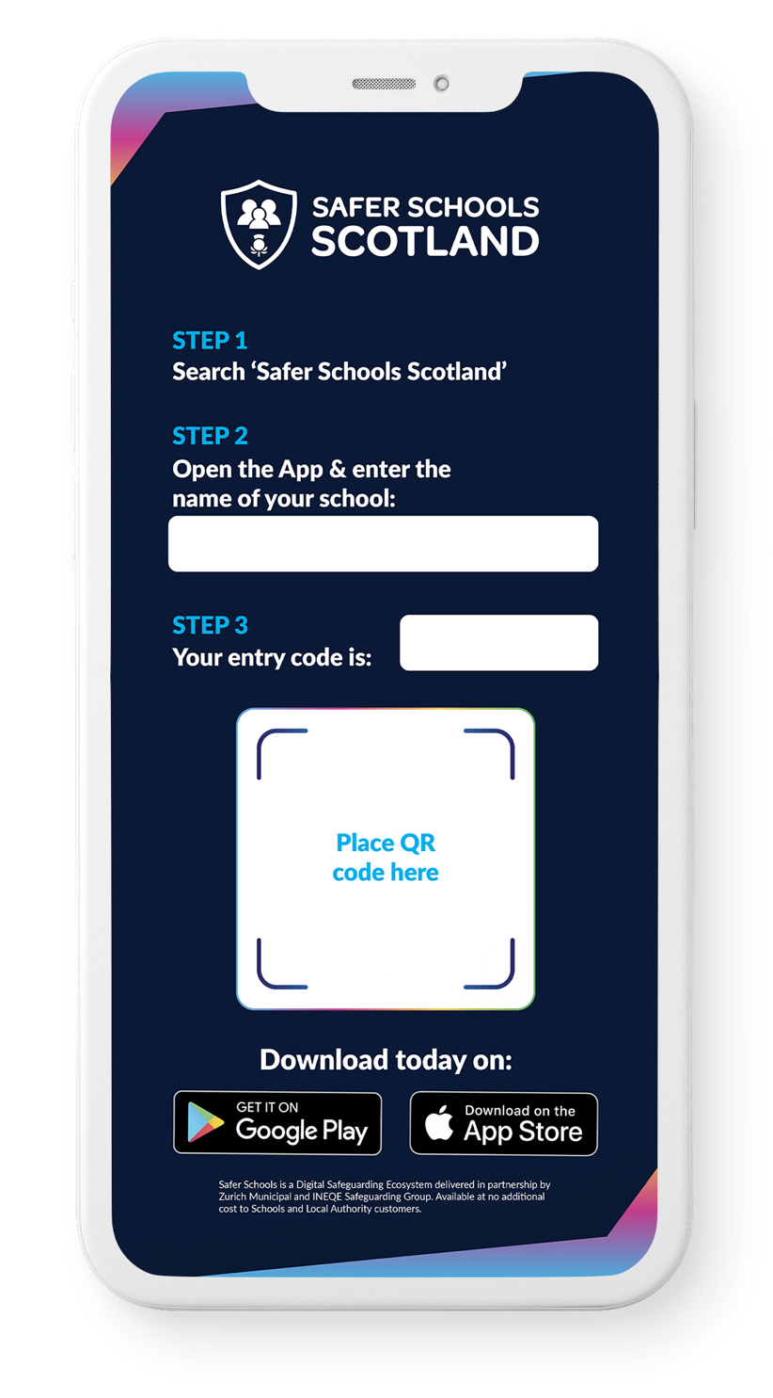

About the App
The App is designed to support and protect children by educating and empowering them both at school and at home. Through their log-in, your children get access to information that is relevant to them and you will receive tips and advice on how to keep them safer online.
Excited? Ready to make
your children safer?
Download the Safer
Schools Scotland App now!

Make sure to enable push
notifications to keep up-to-date
with our tips, advice and guidance
on how to make your children safer.


Educate, empower & protect the entire school community.


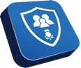
Downloading your App:
Step 1:
If you are using an IOS device, go to the Apple App Store and search ‘Safer Schools Scotland’. If you are using an Android device, go to the Google Play store and search ‘Safer Schools Scotland’.
Step 2:
Select ‘Download’.
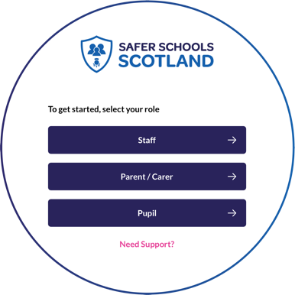
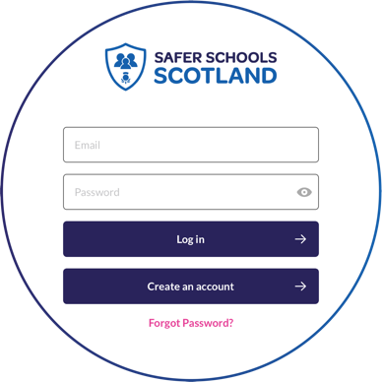

Logging In:
Please follow the below instructions.
Creating An Account:
Step 1
If you haven’t already, please create an account by selecting your role on the login screen of your App.
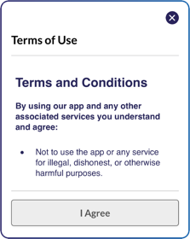
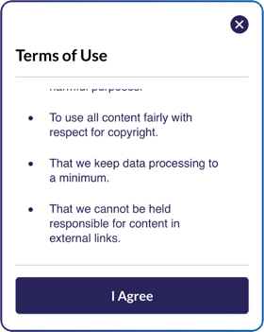
Step 2:
To create and account, click ‘Create an account’ and
input your full name, email, and password you wish to use.
You’ll also be asked to confirm your password. Once you’re
ready, click ‘Register’ and this will create your account.
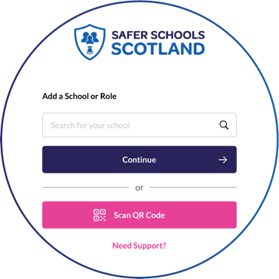
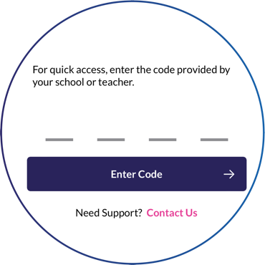
Step 3:
After you register, you will be asked to read and agree to the
Terms and Conditions. After reading and scrolling to the bottom,
the ‘I agree’ button will be available to select.
Step 4:
Time to select your school! To add your school,
simply type your school name in the search bar and click ‘Continue’.
You will then be asked to input your entry code that you have received from your school that is relevant to your role. Type in your code and click ‘Submit’. You’ll be asked to confirm this by clicking ‘Continue’.
Alternatively, if you have been given a QR entry code by your school, when adding your school simply select ‘Scan QR Code’ and scan your code.

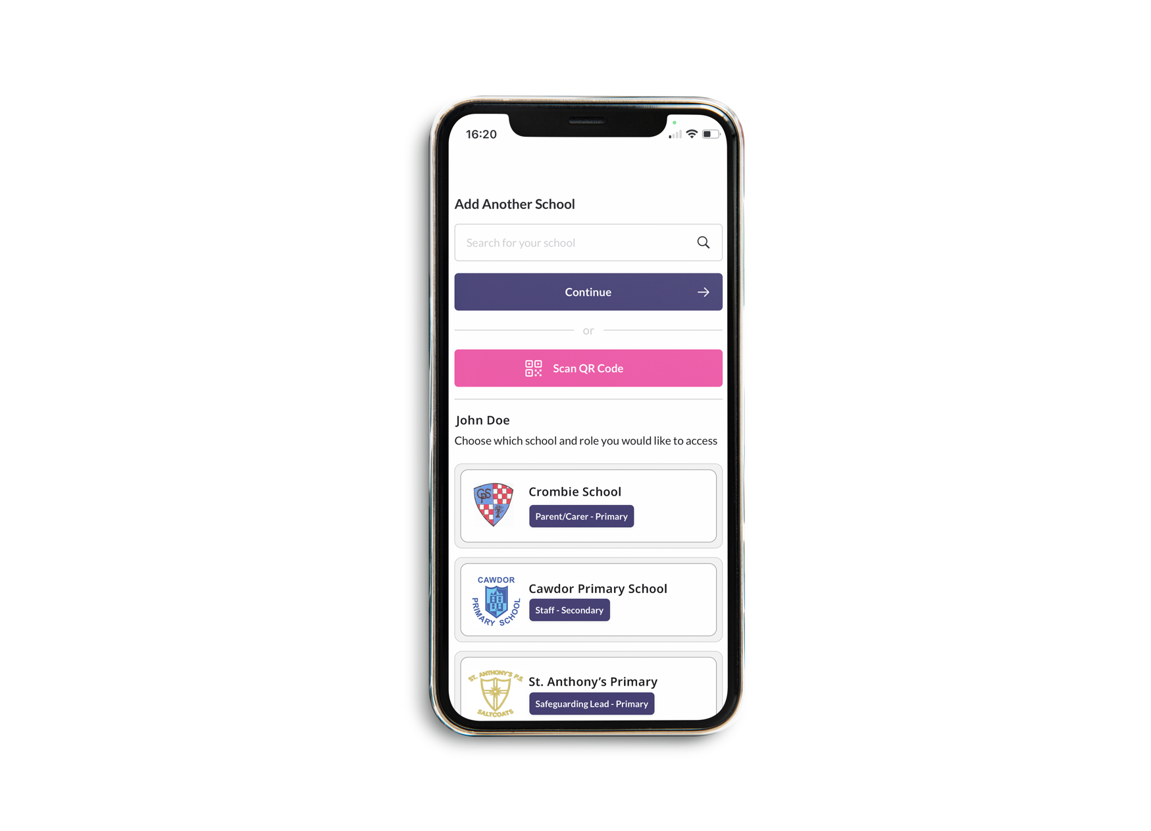

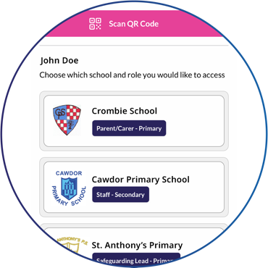
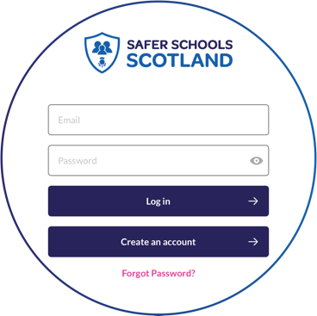
Top Tip: Did you know that your App features Multi-School Login? This means that you are a Staff member in one school with a child in another, or if you are a Parent/Carer of children in different schools, you have access to multiple schools without having to log in and out of the app.
Step 5: To add another school or role, on your Safer Schools app account, click your profile icon on the top right corner, navigate to ‘Account Information’ and select ‘Add Another School or Role’ then simply repeat Step 4.

Logging into your App:
Step 1: When you have opened the App, you should input your email address and password that you used to create your account. Once you’re ready, click ‘Log In’.
Step 2: When you log in, you will see your chosen school(s) that you have added to your account. Simply click the school that would like to view!

