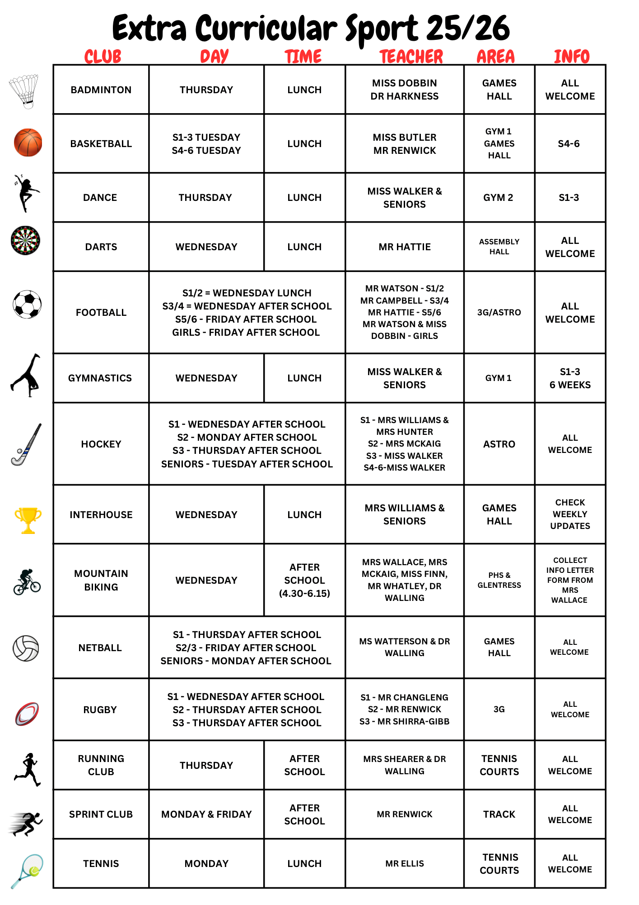

Name of Club | Teacher(s) | Year Group | Monday | Tuesday | Wednesday | Thursday | Friday | Other
Model UN | Mr McMordie | All Welcome |  |  |  | Lunchtime in the LRC (every other week)
Student Parliament | Mrs Marsden-Roy | Elected Members but non-elected Members welcome if they have a specific issue to raise. |  |  |  |  |  | Once a month in M31 or Assembly Hall (Check Bulletin)
PHS Pride | Miss Z Fyfe | All Welcome |  | Lunchtime in M28
STEM Club | Mr Andreou/Dr Harkness | S1 |  |  | Lunchtime in Lab 4
Calm Room | Mrs Maciver | All year groups | Lunchtime in M19 | Lunchtime in M19 |  |  |  | A quite space for reading/games/ iPads/ homework .
Energy Zone | Mrs Rodger | All year groups |  | Lunchtime M30 |  |  |  | A social and fun space for all with an empahais on ADHD learners.
Lunchtime in M19 | Mr Swinton | S1 |  | Lunchtime in DS2
Drama Club | Mr Swinton | S2 | Lunchtime DS2
Drama Club | Mr Swinton | S3 |  |  | Lunchtime in DS2
Language Leaders | Ms Mari | S3 |  | Lunchtime in MC4
Comic Book Club | Mr Savill | All Welcome | Lunchtime in M11
Dungeons & Dragons Club | Mr Clow | All Welcome |  |  |  | Lunchtime in M35 |  | Club runs every second week.
Warhammer | Mr Clow | All welcome | Lunchtime in M35 | Lunchtime in m35 | Lunchtime in M35
Impact Games | Mrs Irvine | All Welcome | Lunchtime in Sports Hall
Tweed Reads | Mrs Stewart | Members only…. but students who are interested may come to a meeting before signing up. |  | Lunchtime
Guitar Club | Miss Pilcher | Some basic guitar experience required | Lunchtime in PR2
Show Choir | Mrs Campbell | All Welcome |  |  |  | Lunchtime in the Pit
Show Band | Mr McLeod | By invitation |  | Lunchtime in the Pit
Jazz Band | Mrs Campbell | By invitation | After school in the Pit
Concert Band | Mrs Campbell | All wind, brass or percussion players welcome | Lunchtime in the Pit
Orchestra | Mr Bisson | Minimum grade 3 standard |  |  | Lunchtime in the Pit
Chamber Choir | Mr Bisson/Mrs Reed | Experienced harmony singers |  |  |  | After school in the Pit
String Orchestra | Mr Whitefield | All string players welcome |  |  | After school in Assembly Hall
Ceilidh Band | Mrs Shaw | All accordion, recorder, violin, flute, chordal guitar welcome |  |  |  | Lunchtime in the Pit
Keyboard Club | Miss McIntyre | S1 & S2 |  |  |  | Lunchtime in the Keyboard Room
Wind Ensemble | Mrs Short | By invitation |  |  |  | Lunchtime in PR2
Interhouse | Mrs Williams and House Captains | Year Group per week |  |  | Lunchtime in Hall 1
Table Tennis | Mr McLean-Foreman/ Mr Martin | All Welcome | After school Hall 2 3.45pm to 4.45pm
Basketball | Mr Renwick | S4/5/6 |  | Lunchtime Games Hall 1.25pm to 1.55pm
Badminton | Miss Dobbin and Dr Harkness | All welcome |  |  |  | Lunchtime in Games Hall
Mountain Biking | Mrs Wallace, Mrs McKaig, Mrs Finn, Dr Walling and Mr Whatley | All Welcome |  |  | After School at Glentress 4.30-6pm

Netball | Ms Watterson/Miss Grieve | S1 |  |  |  | Games Hall 4pm to 5pm
Netball | Ms Watterson/ Dr Walling | S2 |  |  |  |  | After school 1.30pm to 2.30pm
Netball | Ms Watterson/Dr Walling | S3 |  |  |  |  | After school Hall 1 1.30pm to 2.30pm
Netball | Ms Watterson/Dr Walling | Seniors | After school HALL 1 5pm to 6pm
Hockey | Mrs Hunter and Mrs Williams | S1 |  |  | After school ASTRO 4pm to 5pm |  |  | Fixtures for all teams Friday (Aug -Oct) or Saturday (Oct-April)
Hockey | Mrs McKaig | S2 | After school ASTRO 4pm to 5pm |  |  |  |  | Fixtures for all teams Friday (Aug -Oct) or Saturday (Oct-April)
Hockey | Miss Walker | S3 |  |  |  | After school ASTRO 4pm to 5pm |  | Fixtures for all teams Friday (Aug -Oct) or Saturday (Oct-April)

Hockey (Indoor and Outdoor) | Miss Walker | Seniors |  | After school ASTRO/HALL 1 4pm to 5pm |  |  |  | Fixtures for all teams Friday (Aug -Oct) or Saturday (Oct-April)
Football (Boys) | Mr Watson | S1/S2 |  |  | Lunch
Football (Boys) | Mr Gilfether | S3/S4 |  |  | Afterschool
Football (Boys) | Mr Hattie | S5/S6 |  |  |  |  | After school 1.30pm to 2.30pm
Football (Girls) | Mr Watson | All welcome |  |  |  |  | After school 1.30pm to 2.30pm
Rugby (Boys) | Mr Changleng | S1 |  |  | After School 3.45 - 5pm
Rugby (Boys) | Mr Renwick | S2 |  |  |  | After school 4pm to 5.15pm
Rugby (Boys) | Mr Shirra-Gibb | S3 |  |  |  | After school 4pm to 5.15pm |  | Games most Saturday AM
Rugby (Girls) | Peebles RFC YDO | All Welcome |  |  |  |  | After school 1.30pm to 2.30pm
Sprint Club | Mr Renwick | All Welcome | After school  Running track  4pm to 5pm |  |  |  | After school Running track 1.30pm to 2.30pm
Dance | Miss Walker | All Welcome |  |  |  | Lunchtime Gym 2
Running Club | Mrs Shearer/ Dr Walling | All Welcome |  |  |  | After school 4pm to 5pm
Gymnastics | Miss Walker | All Welcome |  |  | Lunch Gym 1
Tennis Club | Mr Ellis | All welcome | Mon lunchtime (gym hall when wet, otherwise on the tennis hard courts)
Crochet | Mrs Davidson and Ms Morrow | All welcome | Lunchtime in M15
Boardgames club | Mrs Irvine | All Welcome |  |  |  | Lunchtime in lab 8
Darts Club | Mr Hattie | All Welcome |  |  | Lunchtime in assembly hall
Sewing Club | Mrs Thomson | All Welcome | Lunchtime M6 | Lunchtime M6
Chess Club | Mr Reilly | All Welcome | Lunchtime - L3 |  | Lunchtime - L3

