Leadership Policy Paper  UNCRC Gold Rights Respecting School | 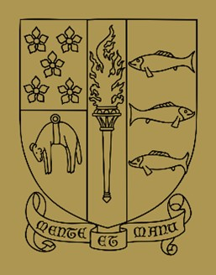

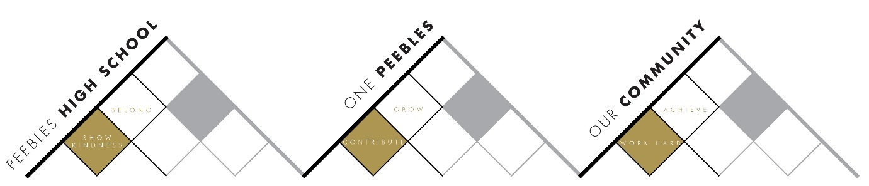

Title | UNCRC Gold Rights Respecting School
Link to school vision and values and UNCRC | Work Hard to Achieve – Article 28 – The right to an education  Show Kindness to Belong – Article 2 – The right to not be discriminated against due to ethnicity, sex, religion, language, abilities, or any other status, whatever they think or say, whatever their family background  Contribute to Grow – Article 29 – The right to an education which develops the personality, talents and abilities of young people
Link to How Good is our School 4 Quality Indicators | 1.3 Leadership of Change  Staff at all levels take responsibility for implementing change and promoting equality and social justice across all their work.  2.2 Curriculum  The curriculum has a clear vision and rationale shaped by the shared values of the school and its community. Our curriculum is grounded in our commitment to securing children’s rights and wellbeing.
Strategic Lead | Emma Ferguson
Date | June 2026
Vision | - By June 2027, children’s rights will be embedded within the culture, ethos, curriculum and leadership structures of PHS.  - Learners, staff and the wider school community will demonstrate an increased understanding of the UNCRC and be able to evidence how rights-based approaches influence learning, wellbeing, participation and decision-making.
Outcome Statement 2024-25  What?  How?  When?  Who? | Learner Knowledge and Understanding of Rights: Young people will be able to advocate for themselves and others in relation to the UNCRC.  - Increase the proportion of young people who report understanding their rights from 43% to at least 70%.  - Increase the proportion of young people who report they "know their rights well" from 9% to at least 30%.  - At least 90% of learners will be able to identify and explain rights relevant to their learning and wellbeing during surveys, learning conversations and accreditation evidence gathering.  Learner Voice and Participation: Young people will feel more empowered to participate in decision-making and feel more valued.  - Increase the percentage of young people who report feeling listened to and involved in decision-making by at least 15% from baseline data.  - Steering Group minutes and pupil feedback will provide evidence of participation from young people in planning, evaluating and leading improvements in PHS.  Staff Understanding and Leadership of Change: Staff feel empowered to discuss rights with young people and make rights part of the culture and ethos of the school.  - Most staff will report a clear understanding of the UNCRC – an increase from 31% to 75%.  - Most staff will be able to identify 2 ways in which they uphold and promote the UNCRC.  June-October  - EF to complete training on Gold Award  - EF to deliver training to staff + launch Gold Award at August Inset  - EF to ‘launch’ Gold Award in the wider school at assemblies  - Form a new Steering Group, involving young people, staff, partners and parents/carers  - Issue questionnaires to young people + staff, including accessible and adult observation versions  - Create Action Plan for Gold. Use feedback from questionnaires to inform the plan  - Under Contribute, all staff complete a return that will be created into a visual. ‘Mini habit’ - how their work links to UNCRC and how they will communicate the link with young people. Staff feel part of a school and global mission and purpose. This can be wider curricular or subject based.  November-December  - Put plan into action  - Gather evidence  - Further staff training at ASM in December.  - Repeat staff ‘mini habit’  January-June  - Review Action Plan to identify where progress has been made  - Repeat questionnaires to identify progress and next steps  - Further staff training at Feb and May INSET.  - Repeat staff ‘mini habit’.
Parent/Carer input | - Parent Council Input
Pupil input | - See above

