Leadership Policy Paper  Rights Respecting Schools & Student Parliament  June 2026 | 

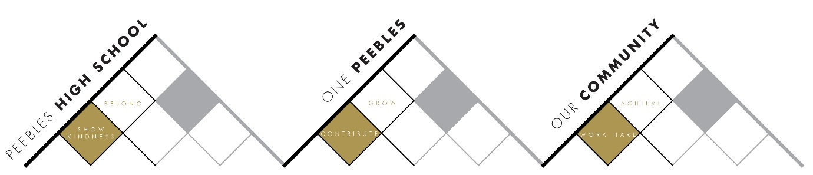

Title | Rights Respecting Schools & Student Parliament
Link to school vision and values and UNCRC | Work Hard to Achieve – Article 28 – The right to an education  Show Kindness to Belong – Article 2 – The right to not be discriminated against due to ethnicity, sex, religion, language, abilities, or any other status, whatever they think or say, whatever their family background  Contribute to Grow – Article 29 – The right to an education which develops the personality, talents and abilities of young
Link to How Good is our School 4 Quality Indicators | 1.1 Self-evaluation for self-improvement  We have developed very effective mechanisms to consult with stakeholders and show how their views inform changed and improvement.
Strategic Lead | Emma Ferguson
Date | June 2026
Vision | For the Student Parliament to be a key component in collecting and sharing student voice which influences the direction of the school
Outcome Statement 2024-25  What?  How?  When?  Who? | June-October  - Form new Student Parliament and decide on Committees. Committees to be led by young people with involvement from SLT and EF. Student Parliament to be more representative of student body.  - Trial new Student Parliament approach on a rolling basis:  - Step 1 - Gather questions/concerns from young people in the school  - Step 2 – Hold Student Parliament to discuss questions/concerns  - Step 3 – Feedback to whole school during Head Teacher online assembly  November-December  - Reflect on new approach – gather feedback as evidence of impact  - Make changes where necessary  January-June  - Continue with new approach  - Review progress and reflect on successes
Parent/Carer input | - Parent Council Input
Pupil input | - See above

