Leadership Policy Paper  Student Leadership | 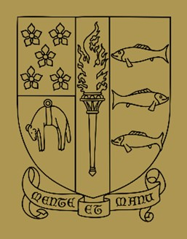

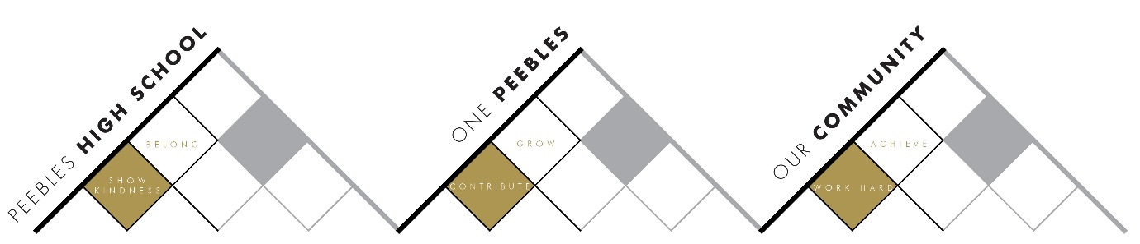

Title | Student Leadership
Link to school vision and values and UNCRC | One Peebles – where everyone can belong, grow and achieve  Contribute to Grow  Article 29 – The right to an education which develops the personality, talents and abilities of young people
Link to How Good is our School 4 Quality Indicators | 1.2 Leadership of Learning - Children and young people leading learning  - We provide a wide range of opportunities and support to ensure children and young people can take responsibility for their own learning, successes and achievements.  - Our learners are developing the necessary resilience and confidence to enable them to make decisions about their own learning and to lead others’ learning.  - They demonstrate this in a range of learning contexts within the school and community. Children and young people value the professional advice and expertise of school staff and others who support their learning and decision-making.  - They actively engage in communication and discussions about their next steps and contribute to planning learning pathways which meet their needs and aspirations.
Strategic Lead | Kevin Ryalls
Date | August 2026
Vision | We take every opportunity to provide meaningful leadership opportunities for young people that develop our One Peebles vision and leadership skills in the young people.
Outcome Statement 2026-7  What?  How?  When?  Who? | Recognise and link to school vision the leadership activities in:-  - Trips, Clubs and Groups  - Volunteering  - Model UN Committee  - Student Parliament  - Language Leaders  - Language Leaders  - MVP  - Prefects and Assistant Prefects  - Senior Prefects  - Head Team  - S6 Level 5 Leadership  - DYW Ambassadors  - Sports Leaders  - House Captains  - Leading assemblies  - Participation in staff meetings  - Participation at Parent Council
Parent/Carer input | - Parent Council
Pupil input | - Core to this
Next Steps 2027-28 | - Link up the work of core groups underlined and build towards a more unified framework by June 2028.  - Kevin Ryalls to develop the capacity and the links to ensure this more unified approach.

