Leadership Policy Paper  Staff Leadership  June 2026 | 

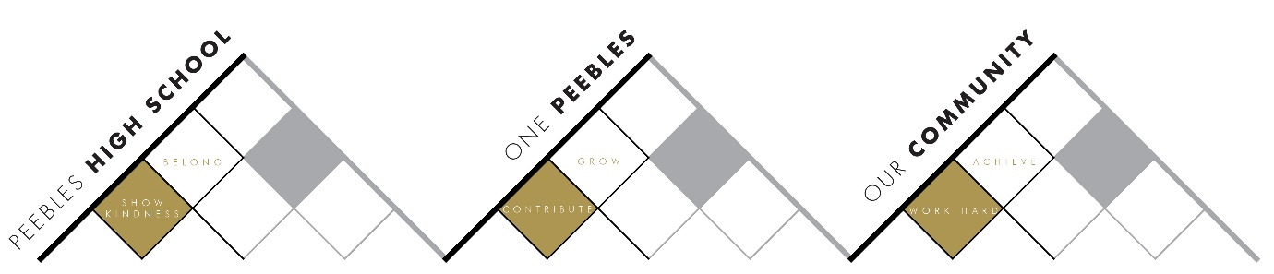

Title | Staff Leadership Framework
Link to school vision and values and UNCRC | Work Hard to Achieve – Article 28 – The right to an education  Show Kindness to Belong – Article 2 – The right to not be discriminated against due to ethnicity, sex, religion, language, abilities, or any other status, whatever they think or say, whatever their family background Contribute to Grow – Article 29 – The right to an education which develops the personality, talents and abilities of young people OR Article 12 – The right to be listened to and respected OR Article 15 – The right to meet with friends and join groups.
Link to How Good is our School 4 Quality Indicators | Quality Indicator 1.1 Self-evaluation for self-improvement  ‘All staff understand that self-evaluation is an integral aspect of our approach to continuous improvement. We use a range of effective approaches to ensure all staff, partners, learners, and other stakeholders are actively involved in our ongoing self-evaluation activities’.  Quality Indicator 1.3 Leadership of Change  ‘Senior leaders create conditions where staff feel confident to initiate well-informed change and are committed to collective responsibility in the process of change’.
Strategic Lead | Kevin Ryalls
Date | June 2026
Vision | All staff with a leadership role  - are clear on vision and outcomes in the context of school vision ie why they are doing what they are doing and how they know if it is making a difference  - take ownership of their own professional development seek through self-evaluation and feedback from colleagues  - ensure pupil and staff voice is central to planning and evaluation and links to school, SBC and national priorities
Outcome Statement 2024-25  What?  How?  When?  Who? | - All leaders with a whole school leadership role (SLT, PTs Pastoral and other staff with leadership roles) complete a Leadership Policy Paper and use Agile Leadership approaches to plan and evaluate  - All Faculty PTs and SLT complete School/Faculty Improvement Plan and Faculty Improvement Reports (SIPs, FIPs and FIRs)  - All leaders who are line managers complete 1.3s self-evaluations and with direct reports  - Leadership Policy Papers, SIPs, FIPs and FIRs and 1.3s provide evidence for improvement in leadership in PHS.
Parent/Carer input | - Parent Council focus on 1.3 in session 2026-27
Pupil input | - Student Parliament focus on 1.3 in session 2026-27
Next Steps 2026-27 | - Input with all PTs and wider school leads in April 2027

