Leadership Policy Paper  School Vision and Values  June 2026 | 

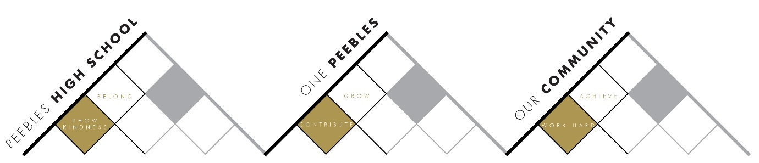

Title | School Vision and Values
Link to school vision and values and UNCRC | Work Hard to Achieve  - Article 28 – The right to an education  Show Kindness to Belong  - Article 2 – The right to not be discriminated against  Contribute to Grow  - Article 29 – The right to an education which develops the personality, talents and abilities of young people
Link to How Good is our School 4 Quality Indicators | 1.3 Leadership of Change  - We are committed to ensuring that we achieve the highest possible standards and success for all learners.  - Our vision evolves through ongoing reflection and debate across the school and community.  - As a result of this active collaboration, the school and community have ownership of the vision, values and aims.
Strategic Lead | Kevin Ryalls
Date | June 2026
Vision | - All members of the school community understand their role in delivering the school vision and values.  - The vision and values inform the learning and work of all members of the school community.
Outcome Statement 2024-25  What?  How?  When?  Who? | - Link school vision and values to UNCRC  - Students and staff have targets and aims linked to the school vision and values/UNCRC  - HT Updates, Assemblies all linked to bringing the vision and values to life.  - All school policies linked to vision and values including the new Lesson Evaluation Toolkit
Parent/Carer input | - Parent Council focus on each value in the meetings
Pupil input | - Student Leadership of assemblies and staff meetings
Next Steps 2026-27 | - Link to UNCRC  - Programme of assemblies  - Lesson Evaluation Toolkit  - Staff UNCRC/Values pledges  - Student Values Tracker

