Leadership Policy Paper  Pupil Support  June 2026 | 

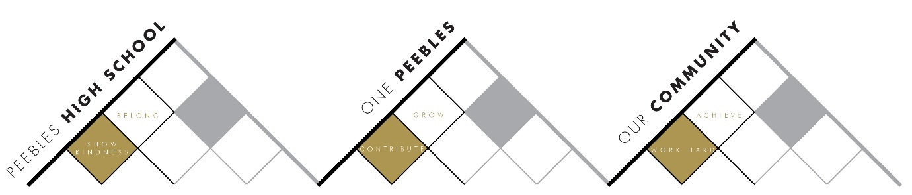

Title | Pupil Support
Link to school vision and values and UNCRC | Show Kindness to Belong – Article 2 – The right to not be discriminated against due to ethnicity, sex, religion, language, abilities, or any other status, whatever they think or say, whatever their family background
Link to How Good is our School 4 Quality Indicators | Quality Indicator 2.4 Personalised Support  Quality Indicator 3.1 Ensuring Wellbeing, Equality and Inclusion
Strategic Lead | Donna Moretta
Date | June 2026
Vision | • Young people are safe, secure and resilient in order to fulfil their potential  • The needs of every individual learner are known and understood by all of their teachers and support staff  • Every young person feels supported in their learning and their emotional wellbeing  • PHS is a place where young people feel that they belong, feel safe and is a place where they want to be  • Barriers to learning are broken down, possibilities are created and potential unlocked  • Improve outcomes for young people by raising attainment and achievement of young people who experience barriers to learning
Outcome Statement 2026-27  What?  How?  When?  Who? | - The Pupil Support faculty which includes Pastoral, Support for Learning, Connect and The Glen will continue to work closely to provide the best possible support for young people.  - The alternative curriculum offer will continue to develop to offer young people more opportunities to engage in learning, both within PHS and the local community.  - The Strategic Support Group (SSG) will focus on supporting young people across year groups, particularly in the areas of attendance, behaviour and attainment.  - What - Pupil Support is made up of Pastoral Care (Principal Teachers and Pastoral Support Assistants), Support for Learning, Inclusion (Connect) and the Enhanced Provision (The Glen). Universal and targeted support is provided to meet the needs of all learners.  - How – every young person has a Pastoral teacher who has responsibility for personal, social, curricular and vocational support (universal) and the delivery of Personal and Social Education.  - Principal Teachers Pupil Support (Pastoral) work with partners both in and out of school to deliver targeted support to meet the needs of young people in their caseload. Support for Learning (SfL) staff receive referrals from pastoral staff, Principal Teachers Curriculum and class teachers.  - SfL staff (teachers and Pupil Support Assistants) offer support for young people in wider school classes and in targeted supported sessions. They are instrumental in the identification of barriers to learning and share strategies to support learning with class teachers.  - The Inclusion (Connect and Outreach) team offer an alternative curriculum which includes health and wellbeing activities and SQA qualifications to engage young people who have barriers to accessing a wider school curriculum.  - The Enhanced Provision (The Glen) team supports young people with complex support needs – both in the Sunflower and Thistle classes and in the wider school.  - Pastoral Pupil Support Assistants (Pastoral PSAs) monitor attendance and support young people and their families to reduce any barriers to attending school. They are part of the House team (House Head, Pupil Support (Pastoral) and Pastoral PSAs) who support young people to engage with learning.  - When – young people are allocated a pastoral teacher when they start S1 and usually they have the same one as they move through the school. Siblings usually have the same pastoral teacher.  - SfL and The Glen staff support any young people in P7 who would benefit from an enhanced transition. Young people are referred to Connect by pastoral staff (in collaboration with parents, class teachers and SfL staff).  - Pastoral PSAs use information from primary schools to identify young people who may be at risk of non-attendance at school and offer targeted support as they transition to PHS.  - Who – Principal Teachers Pupil Support (Pastoral, SfL, Inclusion and Complex Needs), Support for Learning teachers and Pupil Support Assistants (PSAs), The Glen teachers and PSAs, Inclusion (Connect and Outreach) teachers and PSA, Pastoral Pupil Support Assistants and partners.
Parent/Carer input | Feedback from parents/carers (including P7) as part of self-evaluation
Pupil input | Annual survey feedback from young people
Next Steps 2026-27 | Systems, procedures and protocols will continue to be refined and embedded

