

Peebles high school

Progress and achievement

TRACKING, reportING AND parents evening guide 2026 2027

staff
Tracking.
At PHS we record attainment and achievement at various times in the year to support teachers and our tracking procedures.

The attainment reviews are designed to capture assessment data when it is most valid (at a time of reporting or parental engagement). 4 assessment windows are calendared throughout the year to support parents, pupils and staff.

In 2026 2027

Attainment Reviews
- 24th Aug – 4th Sept | S4-S6 | 2026 Results and 2027 plans
- 22nd Feb-6th March | S4-S6 | Estimates tracking and interventions
- 31st May - | S1-S3 | BGE levels progress and ACEL uplift

Senior assessment Windows
- Sept 28th-Oct 9th
- 1st Dec-11t Dec
- Jan 6th -5th Feb
- March 15th-March 25th

To support these discussions the following tracker updates will take place

Senior attainment tracker updates | BGE attainment tracker updates
10th Dec – taken from recent reports | 26th Oct – 13th Nov – Parents evening prep
2nd March – taken from recent reports | 24th-28th May – taken from recent reports and ACEL (16th June)
15th April – taken from final estimate submissions

In the phase of Broad General Education from S1 to S3, most assessment of a young person’s progress is built into normal class teaching. End of unit tests or assessments are used to assess strengths and weaknesses in their learning. These assessments are also based on various skills, which are central to a subject, e.g. reading, writing, talking and listening in English.

In S4 and beyond the regular, continuous 'diagnostic' assessment continues as part of the normal classroom process. However, as a result of most courses in S4 to S6 leading to national certification, formal school examinations are built into the school programme, including preliminary examinations, which are used as a trial run for the actual SQA examinations. These prelims also provide the evidence for Estimate grades, which are sent to the SQA in March of the presentation year.

Our goal is to achieve and exceed this Scottish National standard.

How Good is Our School - Level 5 illustration:

2.3 LEARNING, TEACHING AND ASSESSMENT
Planning, tracking and monitoring
We plan appropriately over different timescales to meet the needs of learners across all areas of the curriculum. Learners are fully involved in planning learning. As a result of our manageable processes to monitor and evaluate learners’ progress we have clear information on their attainment across all curriculum areas. This includes for those facing additional challenges, for example young carers, looked after children and those living with financial hardship. We use this data to evaluate the effectiveness of interventions designed to improve outcomes for all learners

3.2 RAISING ATTAINMENT AND ACHIEVEMENT
Attainment over time
Across all curriculum areas we have raised attainment continuously over time and/or maintained consistently high standards of attainment for all learners. Learners make very good progress from their prior levels of attainment. Our staff make effective use of assessments and their shared understanding of standards to make confident professional judgements about how well children and young people are learning and progressing. A robust tracking system together with effective interventions ensures continuous progress for learners across the curriculum and at all phases in their education, including points of transition. The attainment of individuals and groups has improved consistently over time.

Equity for all learners
We have effective systems in place to promote equity of success and achievement for all our children and young people. We have raised the attainment of all our learners and in particular our most disadvantaged children and young people. All our learners consistently move into sustained positive destinations when they leave school.

REPORTING
What is a school report? In a nutshell it’s a written summary of a pupil’s progress and achievements which will provide valuable guidance primarily to the young people but also parents, carers and other teachers.
We would all like to think that young people and parents and carers appreciate the hours we put into school report writing. However, the reality is that reports are often not as cherished as we would hope. It’s very easy to get them wrong. Wrong name in a copy and paste. Blanket statements for the class such as “We had a great time at Edinburgh Castle”, then finding out the student didn’t attend that day…
But it’s also just as easy to get them right.
- Being specific.
- Writing in simple language.

- Every statement in a school report should include 4 elements:
- Progress - the achievement/success;
- Progress - evidence of that success;
- Next steps - the target;
- Next steps - resources to help meet the target. This would include any supports including AA or differentiation.

For example:
Progress
“Joshua has progressed well in describing physical processes. He is able to accurately label a tectonic plates diagram and sequence how a volcano takes place.”
Next Steps
Reports take time
Unfortunately, school report writing can take time. To make them as personal as we would like to, they can take hours. We want to add personal touches. To streamline reports,
- don’t include those things which have already been covered elsewhere for example a reminder of uploads to Showbie and course content that is on the website will be part of a covering letter so should not be in the report.
- don’t repeat the comments generated by the Effort, Behaviour and Homework grades, but make sure you explain why you have given these grades, especially if they are inconsistent/does not meet expectation.

Personalising school reports is essential.

At Peebles High School we address our report to the young person using their ‘known as….’ name from Seemis. This is their report, and their choice of name is respected.
However, despite all attempts to the contrary, personalisation can go wrong. It can be difficult when trying to remember everything about every child over the whole year, but it is the greatest, valued part of any report. Keeping good records throughout the year on contributions and events will help when the report is due.
Teachers and parents each have a different focus
Teachers may spend ages pouring over assessment data to pick out some key targets and achievements. Some parents do want to have detailed information on their child’s successes and want to help from home whilst others are more focussed on soft skills, confidence and compassion.
So how do you get it right?

Here are 10 top tips to assist you with school report writing:

- Ensure nothing is a total surprise. The report should build on and confirm the ongoing conversations, adding to the parental engagement which has gone beforehand throughout the year. Previous early intervention letters, merit texts and Showbie feedback should be providing a strong foundation for the Progress and Achievement report.
- Keep it simple. Avoid the jargon and acronyms which abound in education. Add details and simple explanations where necessary.
- Be specific. Statements should be simple, and in layman’s terms, but be based on solid evidence. “Joshua did well this year” is not specific enough. Parents may like to hear such a lovely statement, but it gives them nothing to engage with. They will end up asking Joshua what he did well in… which Joshua may also not be sure of the details.
Where possible give a specific % or grade and if you do not want to provide context with a year or class average, use the young person’s own reflections on the grade to provide context. For example,
“I know that you were disappointed by your score, but I see you working hard, and your progress is sound….”
“I agree with your reflection on your recent test that you have made good progress over the year……”
- Use the ‘4 parts’ rule. Each statement in a school report should include 4 elements: the achievement/success; evidence of that success; the target; resources to help meet the target.
- Follow school guidance.
- There is a place for automation. Large sections of copy and paste descriptions of courses information and generic next steps must be avoided but the use of the spell checker can make us look more professional.
- Add resources and links. Don’t repeat what has been already uploaded to Showbie and the covering letter will signpost young people to this feedback, but you may wish to include links to resources that are curriculum-linked. This means that for each target they are directed to high-quality resources for supporting next steps. These could be simple recommended resources such as YouTube channels, websites and even apps, which you know are educationally sound.

- Always maintain positive regard. At PHS we pride ourselves on treating people with respect. Reports are an opportunity to recognise efforts and provide feedback in a constructive way to encourage ownership and learning to take place. Building and maintaining constructive relationships throughout the process.

If a young person has not been in your class use the statement.
“As I have not seen you in class recently, I am unable to comment on your progress but I look forward to welcoming you to class soon” or for those with sporadic attendance, “As your attendance has been inconsistent, my ability to comment is limited but I look forward to welcoming you to class soon”

At choice points always provide a recommended pathway for learning and make sure this is supported by evidence.

- Don’t overdo it. A few key successes and a few targets are great. Make it manageable. A list of 20 successes might seem wonderful but will be very overwhelming.
- Treat it like a face-to-face meeting. When writing the personal part of the report pretend the young person is in front of you, imagining their reaction. This helps in being enthusiastic and realistic – which comes across even on the page. Try to imagine their questions and add a bit of context or answer those upfront, as part of the report.

10 Key questions to support quality reports.

- Is the report addressed to the young person using their ‘known as….’ name from Seemis?

- Have you completed the Progress level and Effort/Behaviour/Homework sections?

- Are comments generated by the Effort, Behaviour and Homework grades aligned with the comments.

- Have you avoided repeating things which have already been covered elsewhere?

- Have you adding evidence used to create the Effort, Behaviour and Homework grades?

- Does it contain 2-4 successes and 2 key targets?

- Does each statement in the report should include 4 elements:
- the achievement/success.
- evidence of that success.
- the target.
- resources to help meet the target. This would include any supports including AAA or differentiation.

- Have you used the spellchecker?

- Are you within the character limit?

- Does the report maintain positive regard.

Evaluation

 |  | Strongly Agree | Agree | Disagree | Strongly Disagree | Don’t Know
I receive helpful regular feedback about how my child is learning and developing. E.g informal feedback and reports. | 2022 | 3% | 27% | 44% | 20% | 6%
 | 2023 | 5% | 39% | 36% | 20% | 0%
 | 2024 | 11% | 45% | 30% | 9% | 3%
 | 2025 | 10% | 45% | 30% | 11% | 4%
 | 2026 | 8% | 51% | 31% | 7% | 3%
The information I receive about how my child is doing reaches me at the right time. | 2022 | 4% | 28% | 35% | 13% | 20%
 | 2023 | 3% | 47% | 29% | 13% | 8%
 | 2024 | 10% | 43% | 26% | 8% | 8%
 | 2025 | 9% | 43% | 29% | 8% | 11%
 | 2026 | 6% | 50% | 27% | 6% | 10%

Progress and Achievement reports
Year | Seemis | Open | Reports to PTs | Distributed via Parent Portal
S3 | Progress and Achievement |  | 18th December
S1 | Progress and Achievement |  | 21st May
S2 | Progress and Achievement |  | 30th April
S2 | Progress and Achievement |  | 8th January  (Progression pathway)
S4 | Tracking and Monitoring |  | 4th December
S5/6 | Tracking and Monitoring |  | 27th November
Seniors | Tracking and Monitoring |  | 2nd March  (Progression pathway and estimate)

progress and achievement report guide
2026-27
In addition to information that teachers write providing specific information on progress made and next steps advice, our reports provide summary information on a young person’s Effort, Behaviour and Homework.
Effort This links to our Peebles Behaviour of being Productive. Following the teacher's instructions immediately and complete all tasks to the best of your ability. Working hard

Behaviour This links to our Peebles Behaviours of being Prepared and Polite. Arrive at class on time. Always wear the correct uniform and bring required materials. Ask for help if you need it. Use polite speech and body language. Listen carefully and talk only when it is appropriate. Be kind, supportive, and understanding. Encourage others and be enthusiastic

Homework This links to our Peebles Behaviour of being Productive and Prepared. The extent to which the learner completes homework on a regular basis, to an acceptable level. Please only fill this in if regular H/W has been given. If this is not the case discuss with your PT.

In order to maximise consistency across the school, we report using four categories: Excellent, Good, Inconsistent and Unsatisfactory.
Excellent (Grade 1) The learner is consistently exceeding expectations
Good (Grade 2) The learner consistently meeting expectations.
Inconsistent (Grade 3) The learner is inconsistent in meeting expectations.
Unsatisfactory (Grade 4) The learner is not meeting expectations

BGE PROGRESS
For several years we have been sending information home on the level achieved for our pupil’s literacy and numeracy Curriculum for Excellence (CfE) levels with the explanation below that many will recognise.
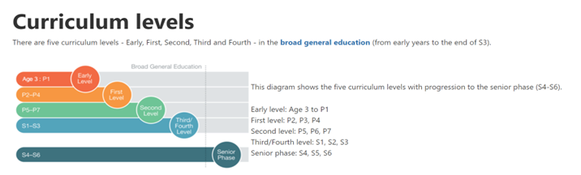

To show progress within CfE levels, which as you can see below can stretch for several years, we will be also indicating their position within a level by reporting if they are:
Beginning: (The learner is beginning to develop the appropriate knowledge and skills at this level.) ​
Working within: (The learner can demonstrate some of the knowledge and skills at this level some of the time.) ​
Near completion: (The learner can demonstrate the knowledge and skills at this level nearly all the time.)
We hope the use of this common language both in school and at home will support conversations about learning and improve parents’ awareness of their young person’s progress.
CfE Level | Stage
Early | The final two years of early learning and childcare before a child goes to school and P1, or later for some.
First | To the end of P4, but earlier or later for some.
Second | To the end of P7, but earlier or later for some.
Third | S1 to S3, but earlier or later for some.
Fourth | The Fourth Level broadly equates to Scottish Credit and Qualifications Framework level 4.  The Fourth Level experiences and outcomes are intended to provide possibilities for choice and young people's programmes will not always include all of the Fourth Level outcomes. Pupils who are working at Fourth Level by the end of S3 are well placed to progress on to National 5 level courses.

BGE PROGRESS AND ACHIEVEMENT INPUT GUIDE
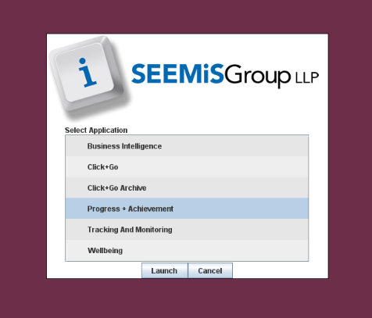

BGE attainment tracker updates
26th Oct – 13th Nov – Parents evening prep
In preparation for parents evening teachers should update current CfE levels on Progress and Achievement.
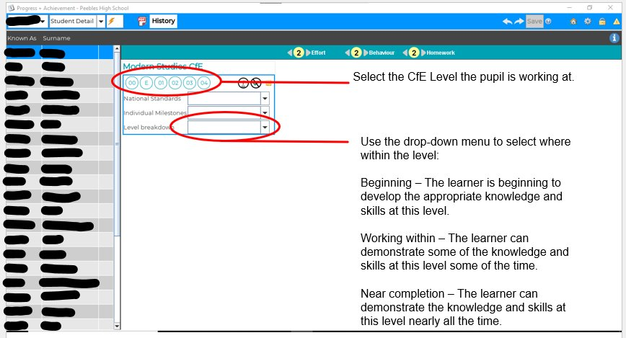

S1, S2 AND S3 FULL REPORTS

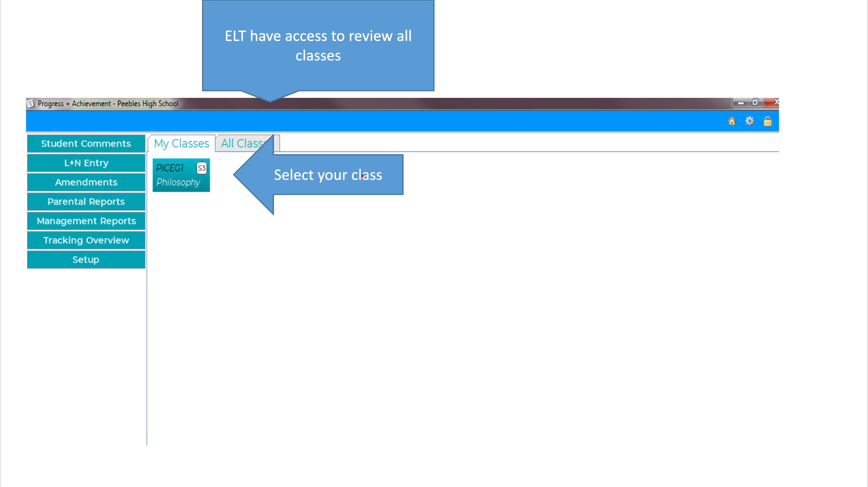
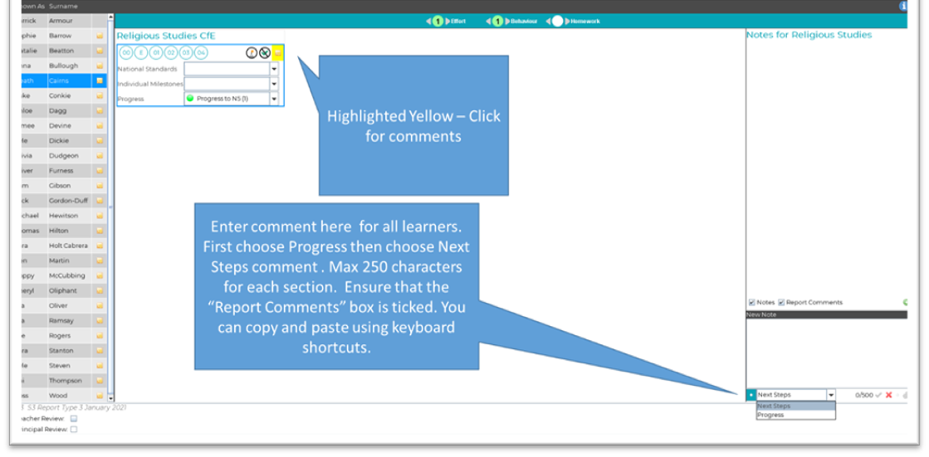

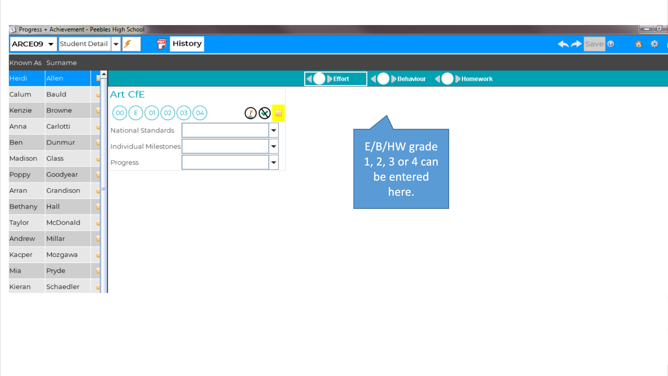

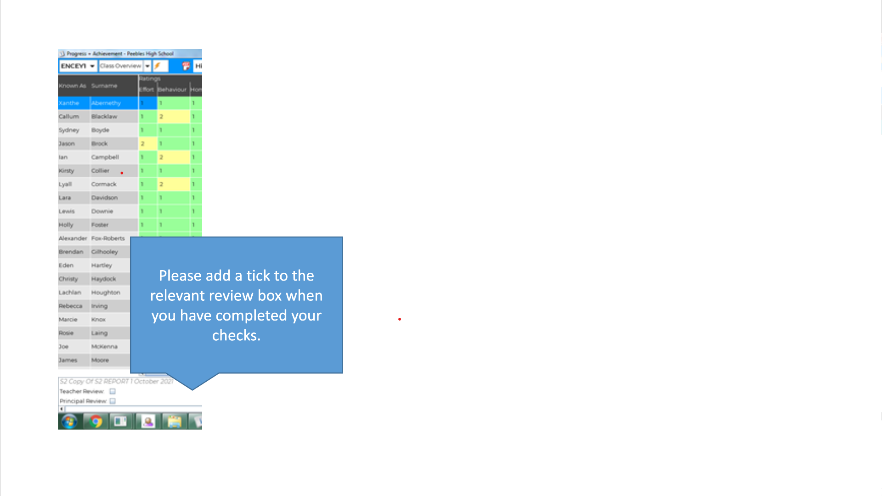

S2 progression report January 8th

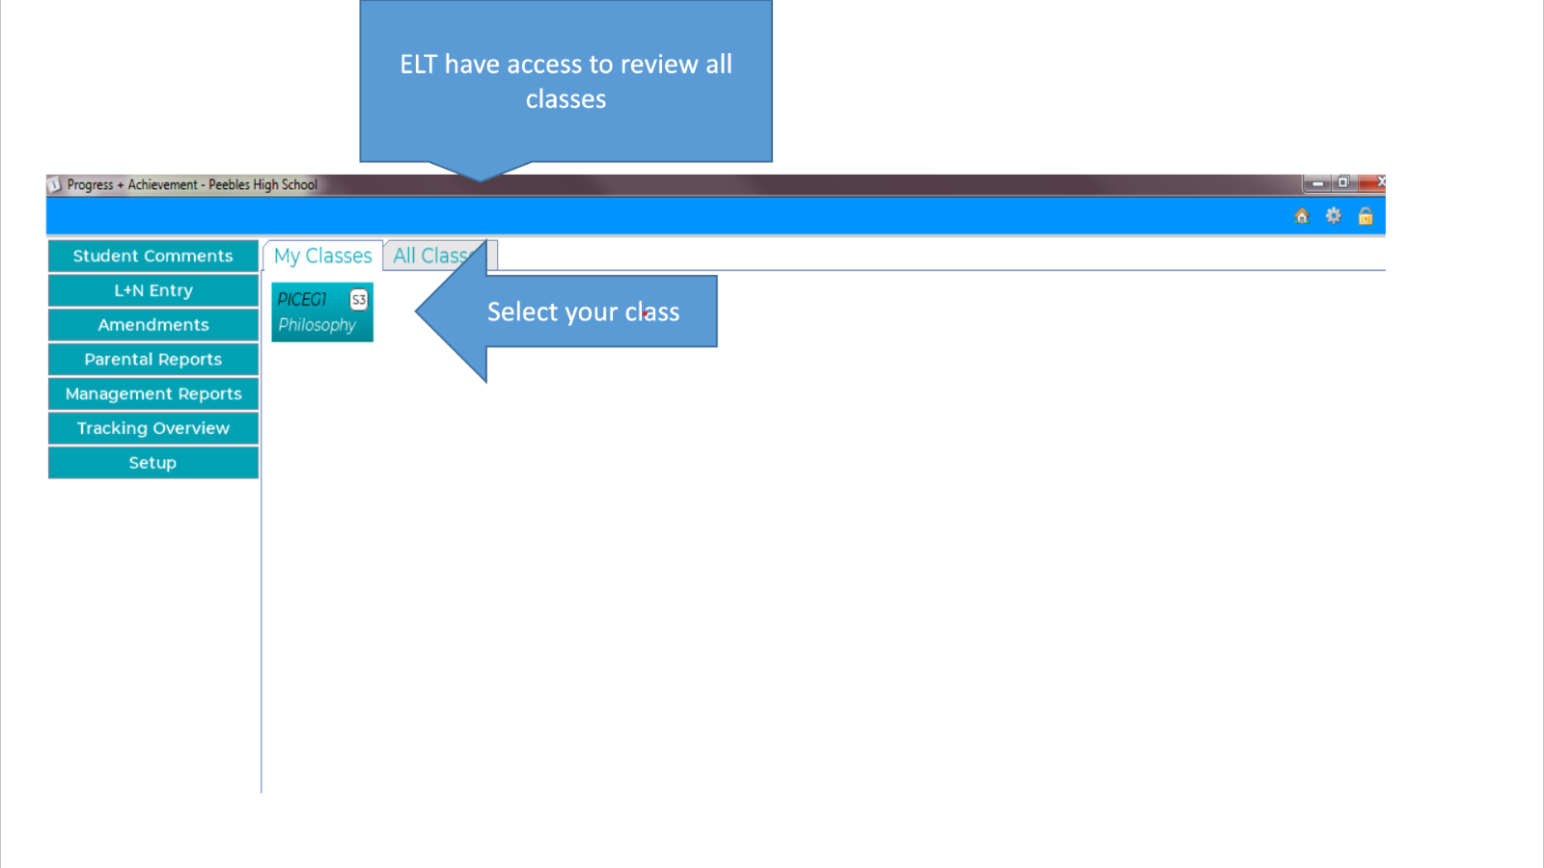

Add a Next Steps comment to support progression choices into S3.

SENIOR PHASE Tracking and monitoring input gUide

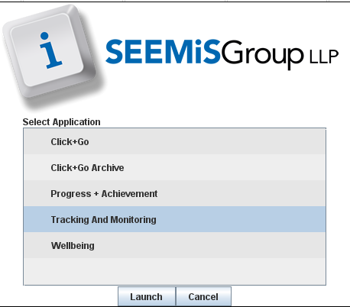

Senior Phase – E/B/HW
Go to teacher view in the Tracking and Monitoring module of SEEMiS and select your class
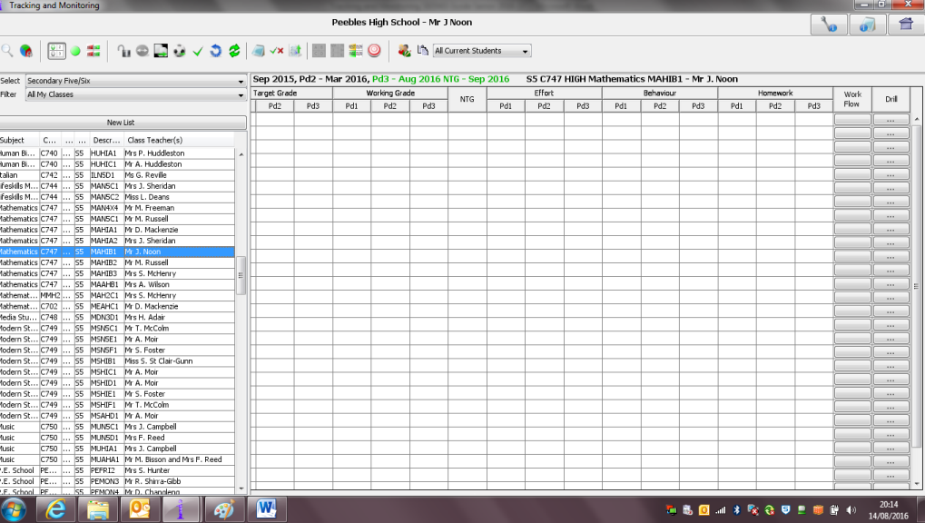6
Open the padlock and change the direction of data entry if preferred
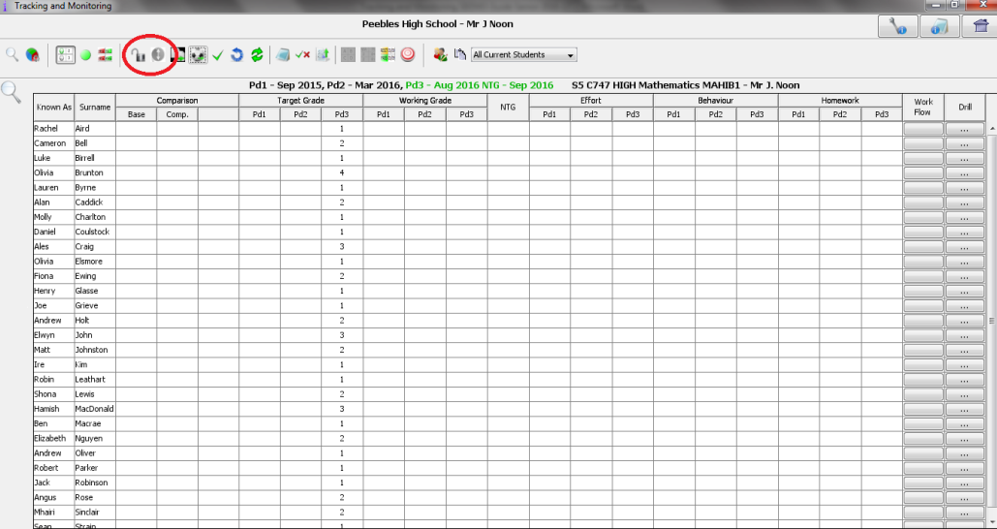
Enter grades 1 to 4 for Effort, Behaviour and Homework as appropriate in the correct tracking period
Grade 1 The learner consistently exceeds expectations.

Grade 2 The learner consistently meets expectations.

Grade 3 The learner is inconsistent in meeting expectations.

Grade 4 The learner is not meeting expectations.

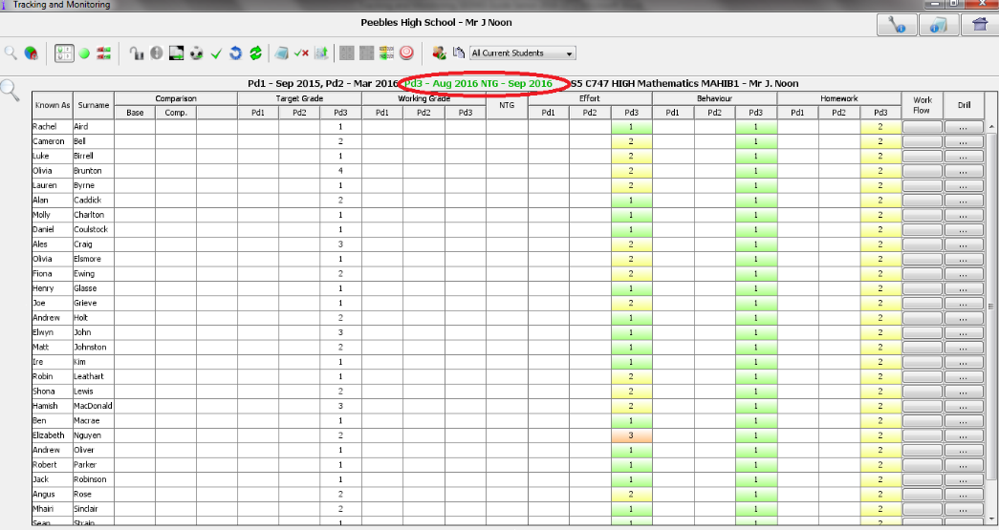

Senior Phase Main Report - Entering Comments

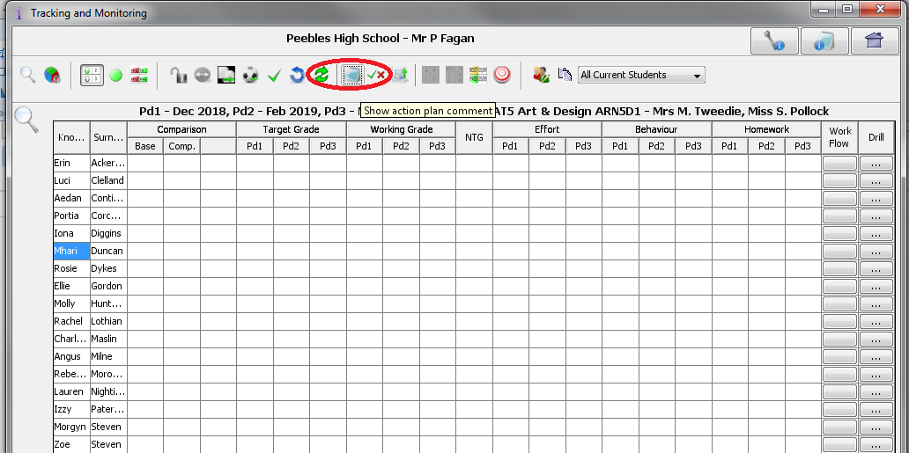

SENIOR PHASE PROGRESS

N2-N4 and NPA courses, such as Journalism (Higher) and Employability (National 4), are internally assessed pass or fail. We report on these courses to confirm whether or not learners are on track to pass. This information appears in the ‘Working Grade’ column:

- 6 On track to pass

- 7 Not on track to pass

N5-AH courses are externally assessed, graded courses. We report on the band which learners are on track to achieve for these courses. While we report on bands, it is the grade in letter form which appears on SQA certificates.

- Working Grade (WG)
The grade, based on a range of evidence, the learner is currently on track to achieve.

This will be included in the main Nov/Dec report and shared with parents.

For the March Progression report and the final export to Qualifications Scotland this will not be shared with parents and the definition will be,

The estimated grade that through a combination of evidence and professional judgement the teacher believe is the best estimate of the learner's final grade.

At the end of the year this grade will be exported to SQA as the learners ESTIMATED grade.

- Next Target Grade (NTG)
The grade, reflecting the teacher’s judgement, the learner could potentially achieve, by the end of the course, if they address their area(s) for development.

This will be included in the main report and shared with parents.

GRADE | BAND
A | 1
A | 2
B | 3
B | 4
C | 5
C | 6
D | 7
No Award | 8
No Award | 9

Checklist for Senior Main Report Nov/Dec
- Effort /Behaviour/ Homework
- Working Grade
- Next Target Grade (NTG)
- Comment (Action Plan)

Senior Phase – Data for Progression Report in March
Go to teacher view in the Tracking and Monitoring module of SEEMiS and select your class
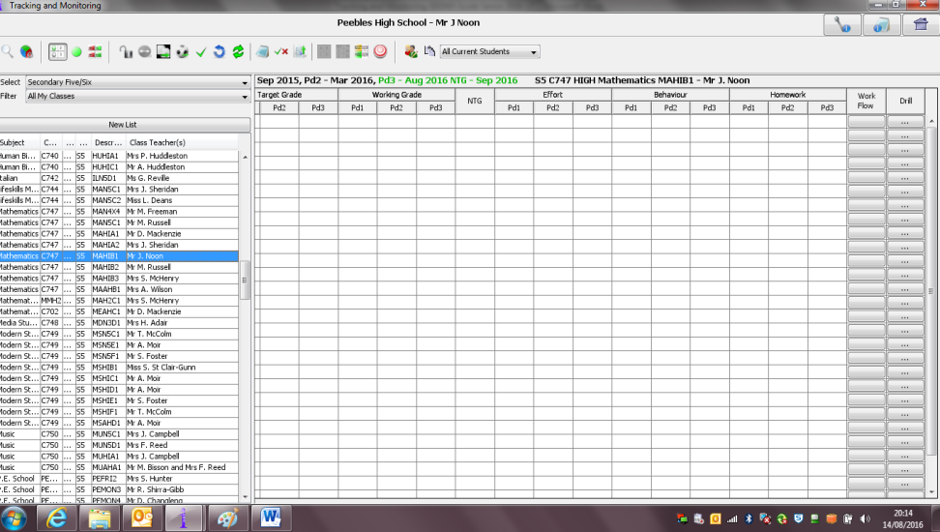
Open the padlock and change the direction of data entry if preferred
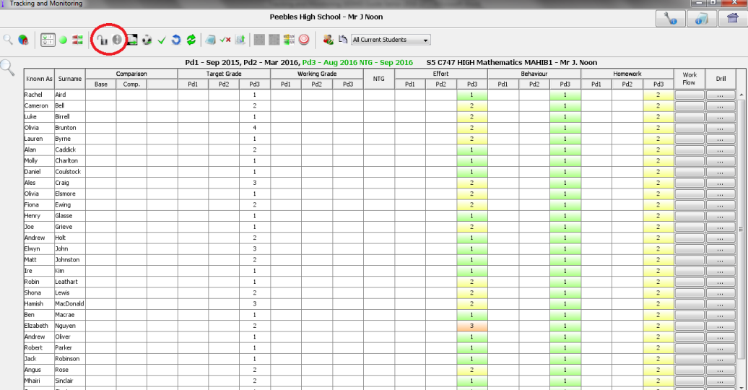
Enter working grade band: 1-9 estimated grade. NPA and N1-4 working grade should be ‘6’ if on track to pass and ‘7’ if off track.
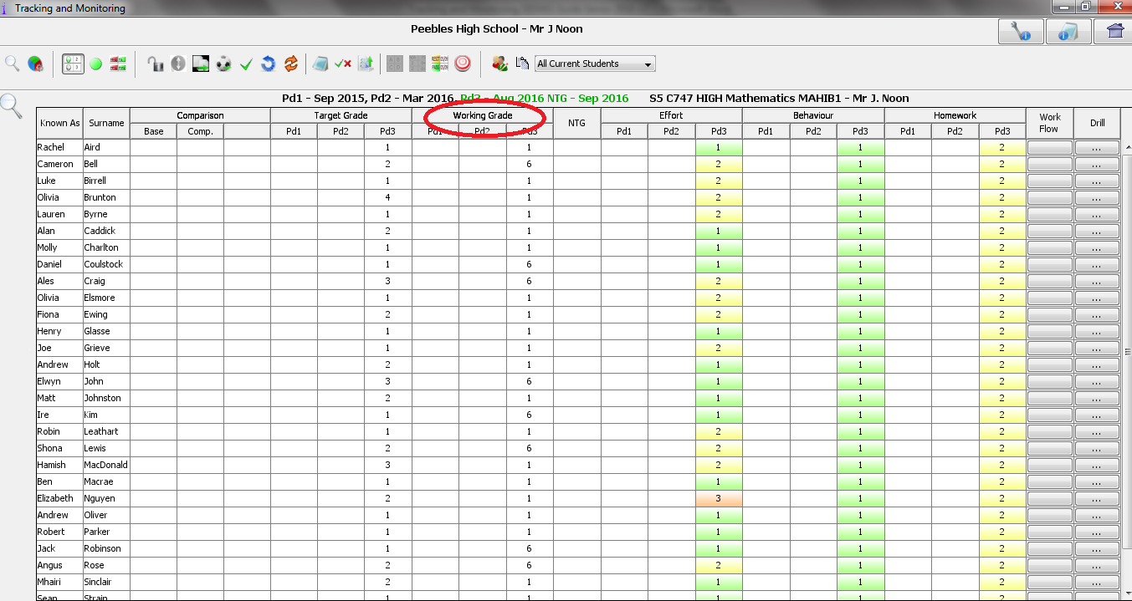

Recommended Progression
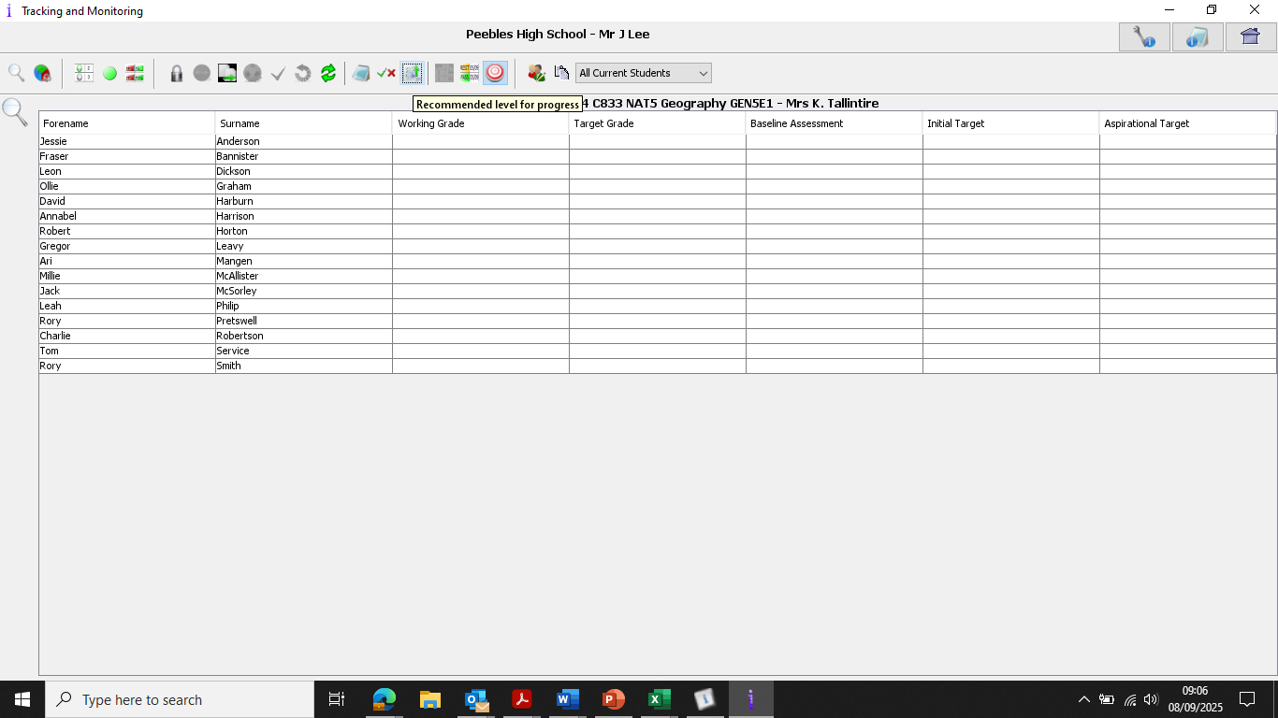

Checklist for Senior Prelim Report
- Working Grade – Estimated Grade
- Recommended level for progress and signpost of prelim result and intervention support.

NO E/B/H, COMMENT AND NO NTG

PARENTS EVENINGS
Calendar 2026 2027 - Progress and Achievement evenings

Event | When | Opens/Closes on Parent booking
S1 Parents Progress & Achievement evening | 11th November | PHS in Person
S1 Parents Progress & Achievement evening ‘mop up’ | 19th November | Online
S2 Parents Progress & Achievement evening. In person | 3rd November | PHS in Person
S2 Parents Progress & Achievement evening ‘mop up’ | 19th November | Online
S3 Parents Progress & Achievement evening. | 26th October | PHS in person
S3 Parents Progress & Achievement evening ‘mop up’ | 19th November | Online
SCQF level 6 & 7 Parents Progress and Achievement evening. (S5 and S6 Higher and Advanced Higher) | 23rd February | PHS in Person
SCQF level 1-5 Parents Progress & Achievement evening. (Mostly S4 National 1 to National 5s) | 18th February | PHS in Person
All SCQF levels 1-7 Parents Progress and Achievement evening. (S4, S5 and S6) Parents Progress & Achievement evening. ‘mop up’ | 8th March | Online

Summary of 2026 2027 changes

BGE internal tracking update – October/November
BGE attainment tracker updates
26th Oct – 13th Nov – Parents evening prep
In preparation for parents evening teachers should update current CfE levels on Progress and Achievement.

SENIOR Working grade definition
- Working Grade (WG)
The grade, based on a range of evidence, the learner is currently on track to achieve by the end of the course.

This will be included in the main Nov/Dec report and shared with parents.

For the March Progression report and the final export to Qualifications Scotland this will not be shared with parents and the definition will be,

The estimated grade that through a combination of evidence and professional judgement the teacher believe is the best estimate of the learner's final grade.

At the end of the year this grade will be exported to SQA as the learners ESTIMATED grade.

- Next Target Grade (NTG)
The grade, reflecting the teacher’s judgement, the learner could potentially achieve, by the end of the course, if they address their area(s) for development.

This will be included in the main report and shared with parents.

SENIOR progression pathway report – March 2nd
- Working Grade = Estimated Grade (not shared with parents)
- Recommended level for progress and signpost of prelim result and intervention support.
NO E/B/H AND NTG. COMMENT and WG ONLY

S2 progression pathway report – January 8th
- In Progress and achievement. Add a Next Steps comment to support pastoral interviews and progression choices into S3.
NO E/B/H, COMMENT AND NO LEVEL UPDATE NEEDED

FAQ – 3.2 Raising attainment and achievement
Tracking, Assessment and reporting
Q1. Are any of the parents evenings online this session?
A1. We're back to face to face for everything other than the mop-ups which are online as always.

Q2. Can parents book the mop up night if its more convenient for them?

A2. I've had some parents e-mail me asking say they're on holiday or they've got work commitments and could they go on the mop-up night. It's meant only for overspill as not all staff will be available.

The other time we've used it is if somebody's off sick and they can't make a parent's evening because, they can't be there, then they could make themselves available for the mop up and inform parents.

I wouldn't stop them from being there if there's capacity because there might be a legitimate reason. Many people have a busy night on the face to face evening. You might have a slot, but they might not be able to get to it.

It is in the working time agreement to do 6 nights so at least one mop-up or perhaps both if they are not needed for a particular year group. It's frustrating if appointments are not taken or missed but ultimately that's time has been committed in the WTA for parental meetings.

Q3. In order to make best use of staff time, could all staff be asked to indicate which parents nights of the 6 available that their teaching commitment requires them to attend?
A3. We ask staff to try to look ahead and plan the best nights for them to attend with their PT based on their timetable.

If staff have time on the parental evenings that they do not have appointments for or perhaps a whole evening (for example they don’t teach that year group) they could attend both mop up to complete the 6 evenings in the WTA or if they don’t need this time for parental appointments be directed to other tasks and these could be done at a place of their convenience.

Q4. I have heard about a new data analysis tool from QS that allows us to look at how well our pupils did on individual questions. Is this available to us?
A4. https://qualifications.shinyapps.io/centre_data/
Item Data (year and subject) – Centre - Download Data

Q5. What has changed this session?
A5. At the back of each policy is a page listing what has changed this session.

Q6. Are there any plans to engage with Lewis from INSIGHT this session?
A6. After several visits from Lewis we have not arranged a meeting this year as we are hoping our data literacy will allow us to interrogate the INSIGHT data which we will do during 1:1 meetings.

Q7. Will pupils have access to their reports this year?
A7. The plan is that after the reports are sent out on parent pay then they will also be uploaded to Showbie so all pupils can access them. This is part of our UNCRC work.

Q8. Senior progression pathway report? When and what are we expected to do?
A8. SENIOR progression pathway report – March 2nd. Working Grade = Estimated Grade (not shared with parents), recommended level for progress and signpost of prelim result and intervention support. NO E/B/H AND NTG. COMMENT and WG ONLY

Q9. Next steps to inform proactive course choices this session?
A9. It's going into the reports as just talked about the senior one that's going in there to say what we're recommended for the next steps March the 2nd. There's the S2 that's new. The S2 progression pathway report for January the 8th. Due to where course choices were and where the information was going out on reports, there wasn't a neat fit there. We needed another piece of data to be able to inform the course choice. There needs to be a next steps which will support pastoral interviews and progression choices into S3.

Q10. Is there any character limit on the main reports to parents?

A10. There's a character limit in the WTA guidance for workload and there is guidance on quality report writing, but there's not an actual cut off character limit on tracking and monitoring or progress and achievement.
Q11. What is the definition of the working grade in December because it sounds more like an estimate?
A11. There are some frustrations with the limits we have on us from Seemis but our definition which is shared with parents is the grade, based on a range of evidence, the learner is currently on track to achieve by the end of the course. Next Target Grade is the grade, reflecting the teacher’s judgement, the learner could potentially achieve, by the end of the course, if they address their area(s) for development.

Q12. What plans are there for the online assessment calendar?
A12. This is to be maintained by PTs. Where possible try to keep to assessment windows but this is the main communication tool signposted to parents and my supplement your own TEAMs or Showbie posts.

Q13. How do we communicate the progression pathway information clearly and timely to pastoral
A13.If we get all teachers to start their next steps on the report with a clear recommendation for progression pastoral staff will be able to view this in their meetings.

