Leadership Policy Paper  Metaskills and Wider Achievement  June 2026 | 



Title | Metaskills and Wider Achievement (Extracurricular clubs and activities)
Link to school vision and values and UNCRC | Contribute to Grow – Article 29 – The right to an education which develops the personality, talents and abilities of young people  Contribute to Grow - Article 15 – The right to meet with friends and join groups
Link to How Good is our School 4 Quality Indicators | Quality Indicator 3.2 Raising attainment and achievement  ‘Overall, our learners are successful, confident, exercise responsibility and contribute to the life of the school, the wider community and as global citizens. They are personally and socially adept and have achieved a range of skills and attributes through a wide range of activities. As they move through their learning pathways they take increasing responsibility for ensuring they continue to add value to their achievements.’
Strategic Lead | Gill Geddes
Date | June 2026
Vision | - Appropriate accreditation and acknowledgement of young people’s wider achievements.  - Improvement in the knowledge of young people in recognising meta-skills, how their wider achievements improve these.  - Improvement in young people reflecting on metaskills as transferable skills across curricular areas.  - Staff more confident in using language around meta-skills in their interactions with pupils.  - Parents and carers have greater understanding of meta-skills.
Outcome Statement 2024-25  What?  How?  When?  Who? | - Improved awareness of what meta-skills are being developed, promoted and reinforced through the various wider achievement opportunities in school and the wider community.  - Greater celebration of wider achievements making young people feel their contributions and known, valued and celebrated.  - Consistency of language throughout curricular areas in conversations around meta-skills, wider achievement and transferable skills.  - Increased confidence from parents and carers about how and why we are promoting meta-skills.  - Improved communication of existing Clubs and societies via Wider Achievement board, social media, daily bulletin.  - Liaison with DYW lead.  - Information on meta-skills pupils are working on collated and available whole-school tracker.  - All posters and promotional material advertising wider achievement opportunities to include reference to meta-skills.  - Triangulation of evidence approach:  - QUANTITATIVE: surveys from staff; pupils; parents & carers  - QUALITATIVE: interviews with staff, pupils, parents & carers; conversations with pupils about their wider achievements to see if they can articulate what meta-skills are and which they are developing; conversations with pupils to see if they can articulate how they are using their meta-skills within areas of their learning; focus groups  - OBSERVATIONAL: observations of wider achievement opportunities to see meta-skills in action and evaluate how this is being put into practice.
Parent/Carer input | - Presentation to Parent Council session 2025-26
Pupil input | - Pupil survey session 2025-26
Next Steps 2026-27 | - Information on meta-skills available to parents on school website as part of a parental '" Support Site".  - Parental information about meta-skills available at all in-person parent evenings.  - Revisit survey – perhaps as part of learning conversations or year group assemblies to ensure as many young people as possible participate  - Focus groups to investigate further why some activities are more popular than others  - Focus on developing knowledge and understanding of metaskills amongst pupils – as part of DYW focus / PSE / learning conversations  - Discussion about metaskills embedded more into teaching and learning – similar to previous posters on “Where can (subject) take you?”  - Enact the proposals and evaluate against target below to ensure continued upward trajectory:  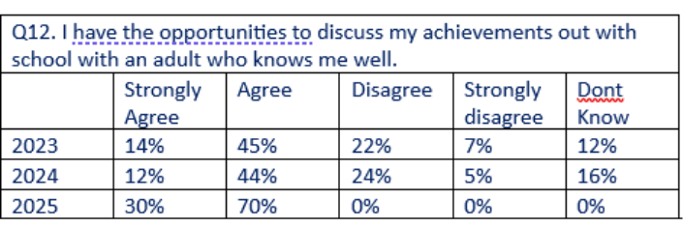  - Evaluate balance of meta-skills being developed for each pupil through analysis of information on whole-school trackers and identify areas for improvement.  - Displays around school about metaskills – including pupil-friendly language and visuals  - CLPL offerings for staff on metaskills  - Greater promotion of what activities are on offer and when – use of plasmas screens, noticeboards, bulletin, HT weekly Sway, etc.  - Information booklet on what each club entails – similar to current SWAG booklet  - “Bring a buddy” and “taster” sessions to allow young people to experience clubs and activities without feeling pressure to commit  - Opportunity for P7’s to see what clubs and activities are on offer during their 2-day visits, including practical demonstrations by pupils already involved as appropriate

