Leadership Policy Paper  Mental Health and Wellbeing  June 2026 | 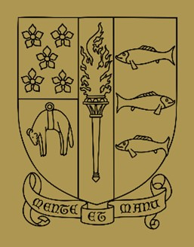

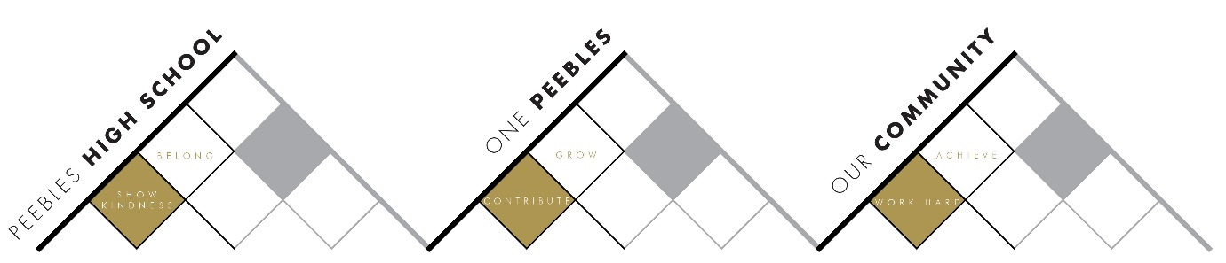

Title | Mental Health and Wellbeing
Link to school vision and values and UNCRC | Article 12 – The right to be listened to and respected
Link to How Good is our School 4 Quality Indicators | 3.1 Ensuring wellbeing, equality and inclusion
Strategic Lead | Siobhan Milligen
Date | June 2026
Vision | To continue to provide a PSE programme that supports young people to make safe and informed choices and having visible student leaders who are involved in impacting change to improve wellbeing of young people at PHS.
Outcome Statement 2024-25  What?  How?  When?  Who? | PHS will be a Nicotine Free School by 2027.  - Baseline surveys with school staff, young people and parents have already taken place which highlighted that the majority of our school community believe that nicotine use is an issue in our school.  - All young people will receive a PSE lesson about Nicotine Free Schools and invited to sign up for an action group.  - A group of 8 students from S1-6 will be selected for the action group and led by Siobhan Milligen. This group will have responsibility for creating a Nicotine Free Charter by December 2026, ready for a launch in January 2027.  - More information will be shared with young people and parents about the nicotine cessation service which young people can self-refer for if over 12 years old.  - Staff have access to e-learning modules around nicotine use and CPD resources will continue to be shared with them.  - By June 2027, pupil self-reported nicotine use will reduce from the 2026 baseline identified in an anonymous PSE survey and pupils will demonstrate increased knowledge of the risks associated with vaping and nicotine products.  Young people will report increased confidence in accessing support, understanding mental wellbeing strategies and discussing mental health concerns.  - New Headstrong resource to be launched with all PSE classes from S1-6 from August 2026.  - Siobhan Milligen will identify which lessons are appropriate for each year group and create a calendar to schedule these lessons throughout the school year. This calendar will be shared with the Pastoral team and she will also lead a session with the team about how to access and use the resource.  - At the end of a block of these lessons we will evaluate the lessons by surveying young people and Siobhan Milligen will also ask the Pastoral team for feedback. This will also be discussed at PSE network events with pastoral representatives from SBC schools, twice in the year.
Parent/Carer input | - Parental survey results used by Nicotine Free action group to inform decisions about the Charter.  - Parents highlighted a need for more information sharing about nicotine pouches which will be distributed.
Pupil input | - Pupil action group will create the Nicotine Free Charter.  - Feedback from young people about the new Headstrong lessons.
Next Steps 2026-27 | Delivery of nicotine lessons to all PSE classes in order to support the creation of the action group.

