Leadership Policy Paper  Lesson Evaluation Toolkit  June 2026 | 

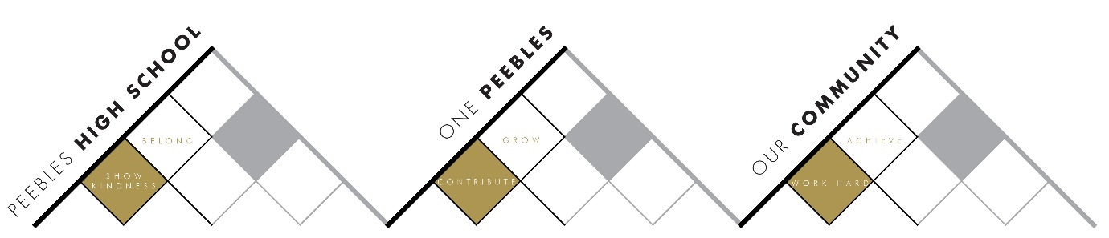

Title | Lesson Evaluation Toolkit
Link to school vision and values and UNCRC | One Peebles vision and values: contribute to grow  UNCRC Articles 12, 28 and 29.
Link to How Good is our School 4 Quality Indicators | This toolkit supports:  QI 2.3 Learning, Teaching and Assessment  - developing a shared understanding of excellent learning and teaching  - promoting reflective practice and professional enquiry  - improving learning through high-quality feedback and collaborative dialogue  - using learner voice and evidence to evaluate impact  QI 1.2 Leadership of Learning  - collegiate professional learning  - coaching and peer learning  QI 1.1 Self-evaluation for Self-improvement  - evidence-informed improvement  - systematic self-evaluation  - identifying strengths and next steps
Strategic Lead | Karen Mooney (Depute Headteacher)
Date | June 2026
Vision | The Lesson Evaluation Toolkit provides a shared understanding of excellent learning, teaching and assessment at Peebles High School. It supports teachers to evaluate and refine their practice, facilitates high-quality professional dialogue and peer feedback, and uses evidence from classroom observations and matched teacher and learner surveys to improve the learning experience and outcomes for every young person.
Outcome Statement 2026-27  What?  How?  When?  Who? | PHS self-evaluation measures updated for 2026–27.  What? Revised Lesson Evaluation Toolkit co-created and in use (Lesson Evaluation Tool for observations and revised matched surveys aligned to this)  How? Teaching and Learning working group draft new observation tool and survey before sharing for wider staff feedback, further revision in response to feedback and launch. In use for Learning Visits and Peer Observations.  When? Aug-Sept: Revise and agree, Sept-Dec: Round 1 Learning Visits or Peer Observations and Matched Surveys, Jan-May: Round 2 Learning Visits or Peer Observations  Who? Teaching and Learning Working Group initially then all staff
Parent/Carer input | Use SBC/HMIE questionnaires, PHS surveys, LTA focus groups
Pupil input | Use SBC/HMIE questionnaires, PHS LET Matched Surveys (BGE and Senior Phase), Student Parliament representatives and Student-Led focus groups to evaluate learner experience.

