Leadership Policy Paper  Staff Leadership | 

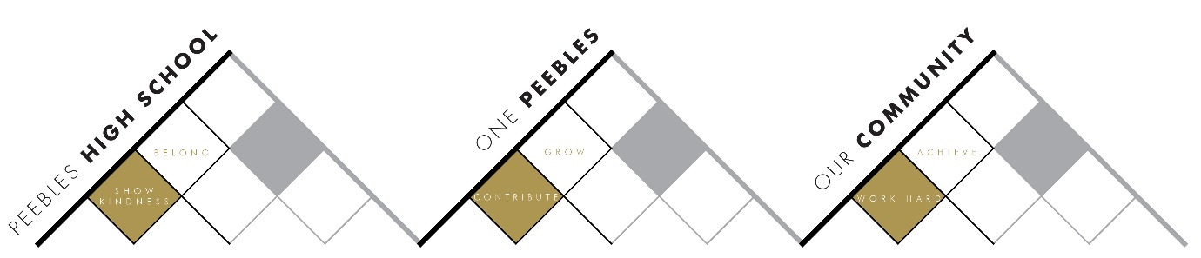

Title | DYW, Employability & Meta-skills
Link to school vision and values and UNCRC | Contribute to Grow – Article 29 – The right to an education which develops the personality, talents and abilities of young people
Quality Indicator | 3.3 Increasing Creativity and Employability
Strategic Leads | - A Reid (SLT DYW, Employability & Meta-skills)  - M Marsden-Roy (PTP DYW)  - F Scott (DYW Coordinator)  - S Wilson (S2 Academies Lead)  - J Lee (SLT Wider Achievement)  - G Geddes (Meta-skills and Wider Achievement)  - K Mooney (SLT Teaching & Learning – Learner Conversations)
Date | June 2026
Vision | Preparing Students for the World of Work  We will ensure that:  - Every student has a clear understanding of, and can articulate, their skills, career pathways and workplace expectations.  - Every student can make meaningful links between their learning experiences and the world of work.  - Every student records and reflects upon their achievements and skills development through the My Achievements and Profiling Tool within My World of Work.
Outcome Statements 2026-27
  What? | How? | Who?
  Improve the capture and recognition of naturally occurring DYW activities across the school. | Develop systems to identify, record and celebrate DYW experiences across faculties and year groups. | F Scott
  Increase faculty engagement with DYW opportunities. | Promote and support participation in DYW Pledge offers and employer partnerships. | F Scott
  Strengthen cross-sector working with Tweeddale cluster primary schools. | Expand S6 DYW Leadership Group involvement in primary transition and DYW activities. | F Scott / M Marsden-Roy
  Regular review of the Tracking and Monitoring (TOM) system. | Focus on participation, progression and impact measures. | A Reid
  Develop and embed Work-Based Learning (WBL) initiatives. | Increase learner engagement in work-based and employer-led experiences. | F Scott
  Deliver a high-profile Apprenticeship Week programme. | Coordinate activities and employer engagement linked to apprenticeship pathways. | A Reid / F Scott / M Marsden-Roy
  Further develop S2 Academies. | Embed My World of Work profiling tools and strengthen sector-based learning opportunities. | S Wilson / F Scott / A Reid
  Increase faculty business partnerships. | Support every faculty to establish and develop a Faculty Business Partner through DYW Pledges. | F Scott
  Increase access to universal DYW opportunities. | Deliver Career Insight events, sector-focused afternoons and mock interviews for all school leavers. | A Reid / F Scott / M Marsden-Roy
  Enhance the recognition of meta-skills through Wider Achievement. | Develop processes for capturing, tracking and celebrating meta-skills development. | G Geddes / J Lee
  Embed meta-skills within learner conversations. | Use learner conversations to support regular reflection and recording of meta-skills. | K Mooney
Parent/Carer input | Parent Council representatives involved in Career Fair organisation  Parent Council representative on PHS DYW Steering Group  Parents/Carers have opportunity to feedback on processes following groupcall communications  Parents/Carers have opportunity to feedback at Careers Fair
Student input | S6 DYW Leadership Group  Feedback/evaluation on Primary Lessons from P7 students  S2 Academies Pupil Parliament Group
Next Steps 2027-28 | Continue to embed use of profiling tools across Academies, subjects and extra-curricular.  Analysis of data from Profiling Institutional Dashboard used to inform school decisions e.g. targetted activities for underreported metaskills  Continue to develop cross sector DYW links, supported by DYW Co-ordinator

