Leadership Policy Paper  Staff Leadership | 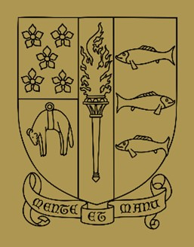

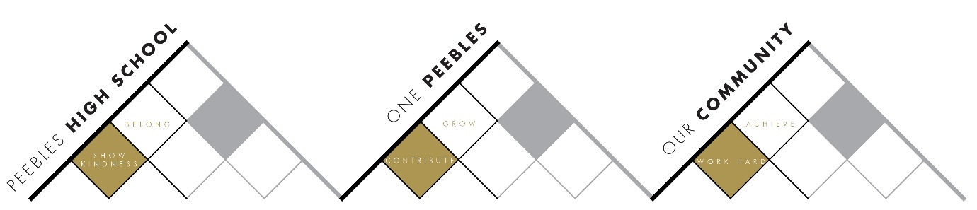

Title | Curriculum & Pathways
Link to school vision and values and UNCRC | Contribute to Grow  Article 29 – The right to an education which develops the personality, talents and abilities of young people
Link to How Good is our School 4 Quality Indicators | 2.2 Curriculum
Strategic Lead | Alasdair Reid
Date | August 2026
Vision | A varied curriculum that meets the needs of all, enabling and inspiring students to reach their full potential.
Outcome Statement 2026-7  What?  How?  When?  Who? | We will continue to embed a curriculum that maintains a Broad General Education for all, while continuing to meet the needs of all in the Senior Phase  What?  - Quality Assurance of new S3 equity between subjects  - Ensuring returning S5 learners undertaking N5s are having needs met in new curriculum structure  How?  - Evaluation of S2 into S3 course choice guidance  - Evaluation of new S5 curriculum structure  When?  - Throughout the session  Who?  - A Reid
Parent/Carer input | - Parent Council
Pupil input | - Evaluation of new S5 learner experiemce
Next Steps 2027-28 | - PHS S6: Advanced Highers & School Service

Appendix: PHS Curriculum Structure
S1
5 periods of | Maths, English
4 periods of | Science
3 periods of | Languages, PE
2 periods of | Music
1 period of | Drama, Art, Technical, Business & ICT, Geography, History, Social Subjects, Personal & Social Education, RMPS

S2
5 periods of | Maths, English
4 periods of | Science
3 periods of | Languages, PE
2 periods of | S2 Acacedmies
1 period of | Music, Drama, Art, Technical, Business & ICT, Geography, History, Personal & Social Education, RMPS

S3
4 periods of | English, Maths
3 periods of | 7 Optional Courses
2 periods of | PE
1 period of | Personal & Social Education, RMPS

S4
4.5 periods of | Maths and English (including one weekly rotation period)
4 periods of | 5 Optional Courses
2 periods of | PE
1 period of | Personal & Social Education, RMPS

S5
Either | A minimum of 6 courses
Or | 5 Level 6 courses plus School Study
2 periods of | PE
1 period of | Personal & Social Education, RMPS

S6
Either | A minimum of 5 courses
Or | 3 L7 courses
Plus | - One other course at any level  - or School Service
5 periods of | Core Study in Library
2 periods of | Leadership
1 period of | Personal & Social Education

