

PHS Parent Council
2 February 2026
Hybrid Meeting

Attendees

Ellie Johnstone, PC Chair (Chair) | Claire Barrett, PC Secretary
Kevin Ryalls, Head Teacher (HT) | Tristan Compton, PC Vice Chair & Trustee, FoPHS
Donna Moretta, Deputy Head Teacher | Faye Scott, DYW Coordinator for PHS

Apologies: Gillian Moran
7 parents joined the Parent Council meeting. Parent comments and questions are shown in bold italics with answers given below. Actions are in red and action tracker is at the end of these minutes.

Chair’s Update
The Chair welcomed everyone to the meeting, opening with a reminder that she and Claire will be standing down after the May meeting, so parents are invited to get in touch if interested in either of these roles: Parent Council Chair and Secretary.
- The fundraising during the old school to new school building transition was very successful raising around £13k combined. This will go towards the Opportunities pot. The Chair expressed thanks to all involved.
- The recent S1 Family Learning Event was really successful with parents and young people very engaged, and a diverse spread of activities on offer. Metalwork was extremely popular. Everyone had a great time, with lots of positive comments on the night. HT commented that this may become part of the transition plan from P7.

Dyslexia & Autism Support Update – Mrs Moretta
Mrs Moretta attended to present on “Meeting Learners’ Needs”. The slide pack is at the end of these minutes.
Autism is present in about 10% of young people and it is increasing. Dyslexia about 12%. ASN generally 49%. This is increasing all the time. Learners do not need a diagnosis, the support is needs-led.
Significant progress has been made in supporting dyslexic and autistic learners as part of the school’s School Improvement Plans (SIP) for 2024/25 and 2025/26. For dyslexia, a working group involving staff, parents/carers, educational psychologists, and young people collaborated to produce a new policy and toolkit, streamline referral systems, and enhance literacy profiling. Staff undertook extensive professional learning through modules, After School sessions (ASM), in-service days, and training sessions.
Survey data from young people showed improvements in areas such as feeling recognised as dyslexic learners, confidence in asking for support, and the use of accessibility tools, though some areas—like teacher discussions about learning needs—are still areas of improvement. Parental feedback also indicated substantial improvements in perceptions of staff understanding and support. HMIE praised the school’s strong focus and methodology in addressing dyslexia.
The School Improvement Plan (SIP) for autism (2025/26) aims for most autistic learners to feel recognised and supported by June 2026. Progress to date includes establishing a similar multi-stakeholder working group, producing a policy and toolkit, delivering After School sessions and in-service training, and sharing good practice through leadership teams. Young people and parental surveys highlight areas for growth, particularly around staff understanding and communication about learning needs. Next steps include continued professional learning, further surveys to measure impact, and ongoing support from Principal Teachers of Pupil Support.
At the meeting, parents acknowledged the significant improvements in dyslexia support, and some (anonymous) real life examples were shared.

Q&A
Where do the referrals for dyslexia come from?
Class teachers, Support for Learning teachers or parents via Pastoral teachers, sometimes self-referrals from pupils.
Are some faculties embracing this more than others?
I would expect some staff would more than others but as a whole school this has been a priority. There are SFL staff assigned to faculties too.
Was there a variation in age groups in the survey?
Unsure but the older ones were most vocal with HMIE so they must have seen a change.
What process has been put in so that children in primary school with support already in place, are identified and will get the help they need when they move up to high school?
The Support for Learning (SFL) teachers from primary school are part of the working group, policy has been shared with primary schools. A SFL teacher is assigned to the primary schools, they find out the info and it comes up to PHS and systems are better with more info than before. Catherine Ramage, the Principal Teacher for SFL meets monthly with SFL teachers from primary schools to share info on pupils. There is an open literacy file on the pupil and that comes up to high school now, it is not started again from scratch.
Are links established with CAHMS to work together?
Waiting lists are so long but we work with what we’ve got and the needs we’re seeing. It is needs-led. The links are already there.
Has the new school building made a difference?
Yes, it’s much calmer, the classrooms are less cluttered, the Glen is fantastic, the pupils are less distressed in general.
To wrap up the session, Mrs Moretta mentioned that there will also be work on DLD this year – Developmental Language Disorder. Faye mentioned she is currently doing her Masters and researching Autistic Women, their struggles and how they have overcome them. A lot is about awareness and lived experience is central to this work. It is important to hear success stories which we can learn from.

Developing the Young Workforce (DYW) – Faye Scott
Faye Scott joined the meeting to introduce herself as the new DYW Coordinator at PHS, having started in August 25. DYW works to help pupils prepare for the world of work by connecting learning with real industry experiences. The organisation operates across Scotland, with coordinators in each secondary school, allowing close collaboration with local employers. The focus is on building employability skills and raising awareness of career pathways through activities such as hands-on skills days, workplace visits, and industry-led class talks. Recent examples include a Construction Skills Day and employer visits supporting health and hospitality courses. DYW aims to involve as many young people as possible in work-related learning and is actively seeking partnerships with local businesses and individuals to support pupils through talks, visits, mock interviews, or work experience opportunities.

Faye invited any local businesses or parents with links to please get in touch if you wish to discuss anything or can help.

A parent offered to work with Faye on Health, and the HT mentioned the school is always pushing for work experience with NHS and SBC as they are large employers in the area but it’s always difficult securing work experience with them.

Faye also appealed for any contacts in trades, hair & beauty, garages, as these are popular requests for work experience.

Head Teacher update
There was no specific HT update at this meeting. The HT updates are shared every Friday to all parents/carers via email and the school website.

General Q&A
Arts & Culture – it would be great to see the arts shared thru the Friday bulletin – are there any plans?
Drama are planning to have a show. We’re keen to get music out and about in the school.

Uniform – Brown & Out has ceased trading?
Border Embroideries will supply the school uniform from now on. They are based in Greenlaw nr Duns and have an online shop.

The meeting closed at: 8.20pm
Next Meeting: Weds 18 March, 7pm

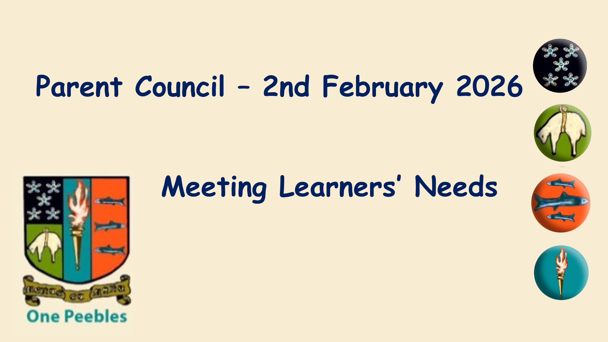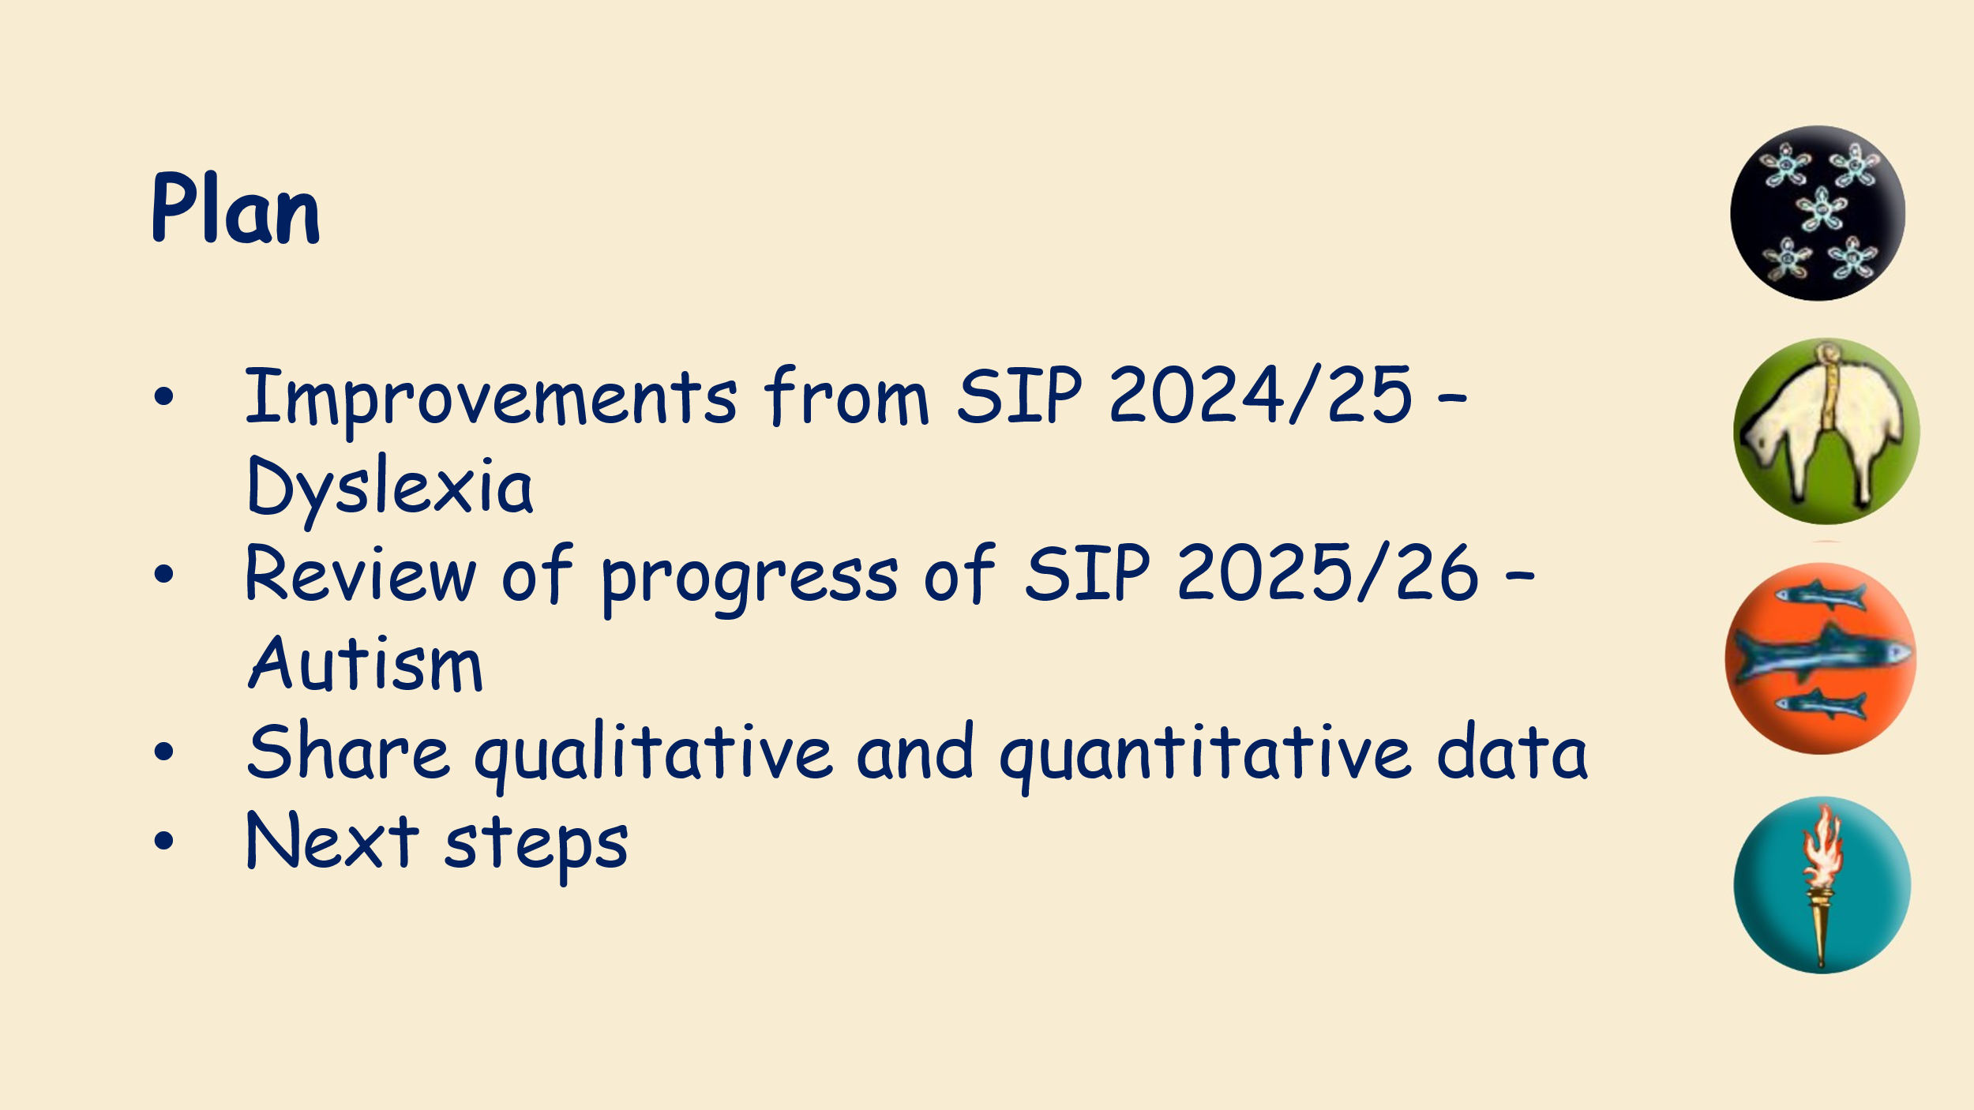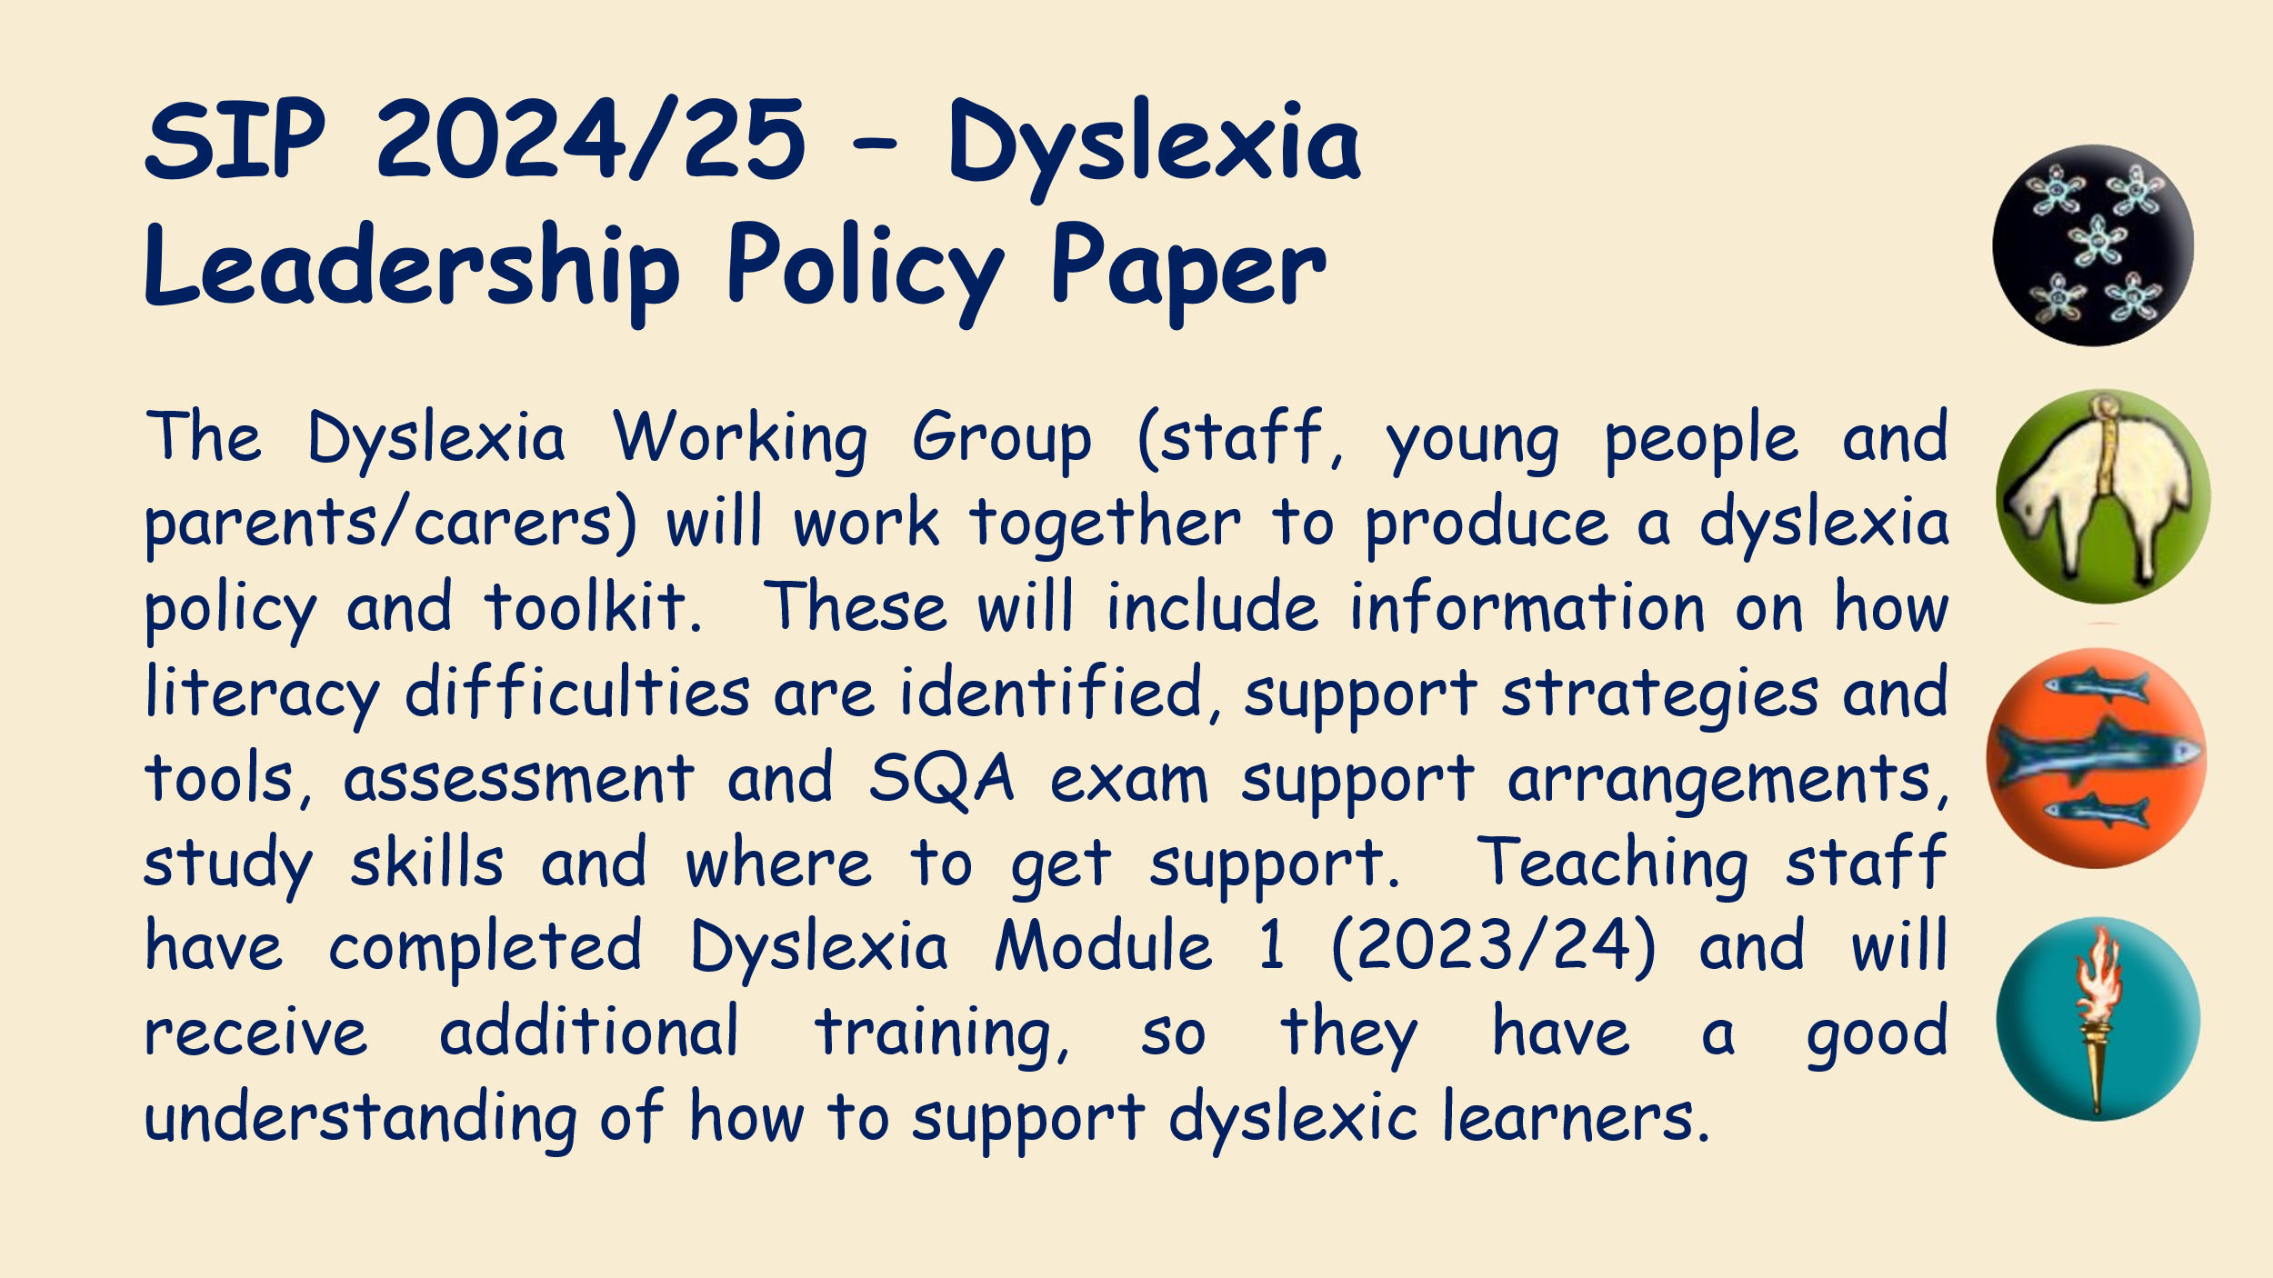
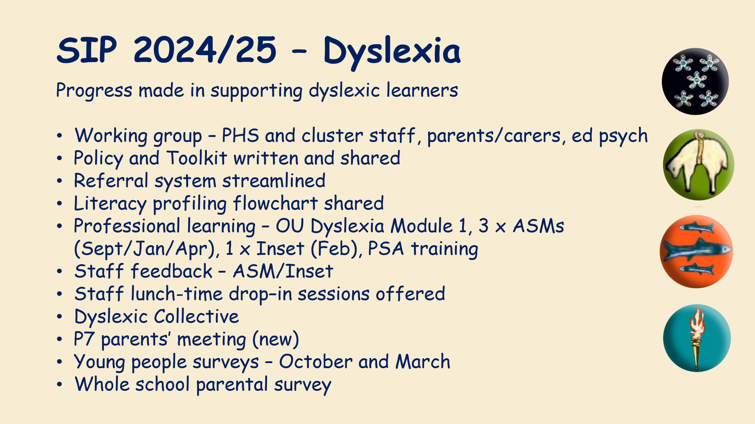
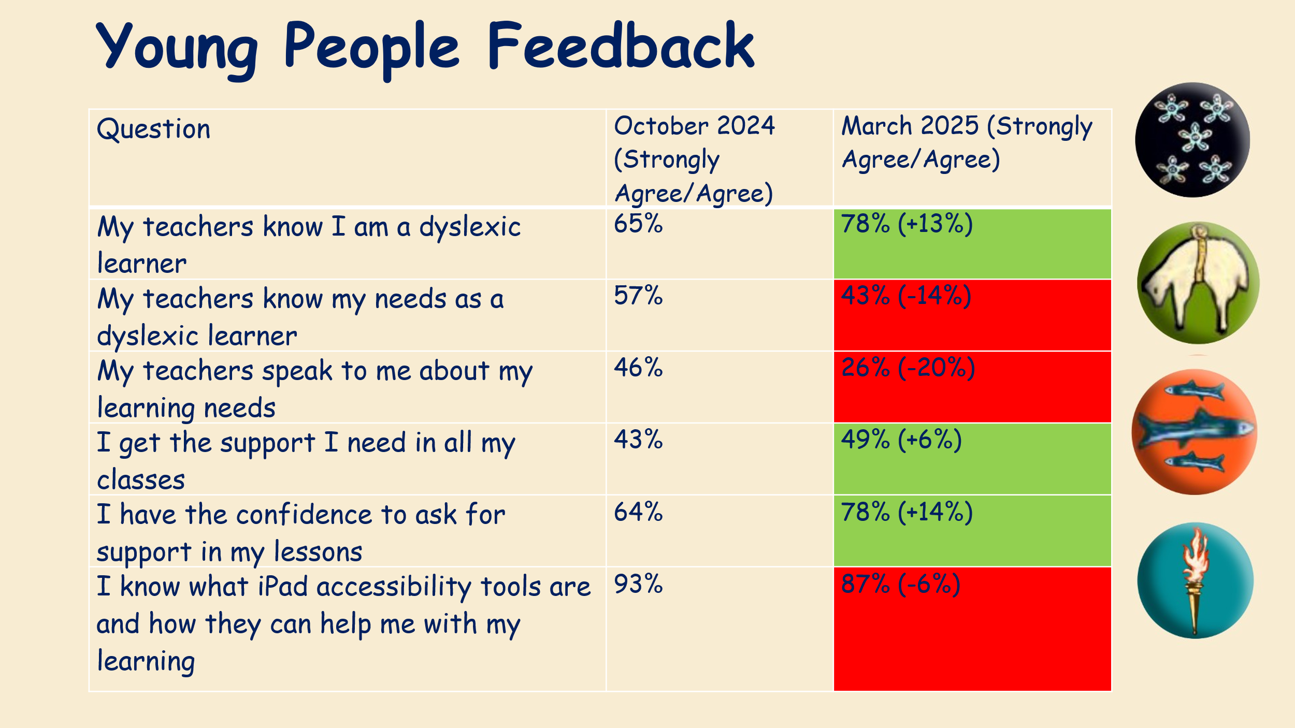
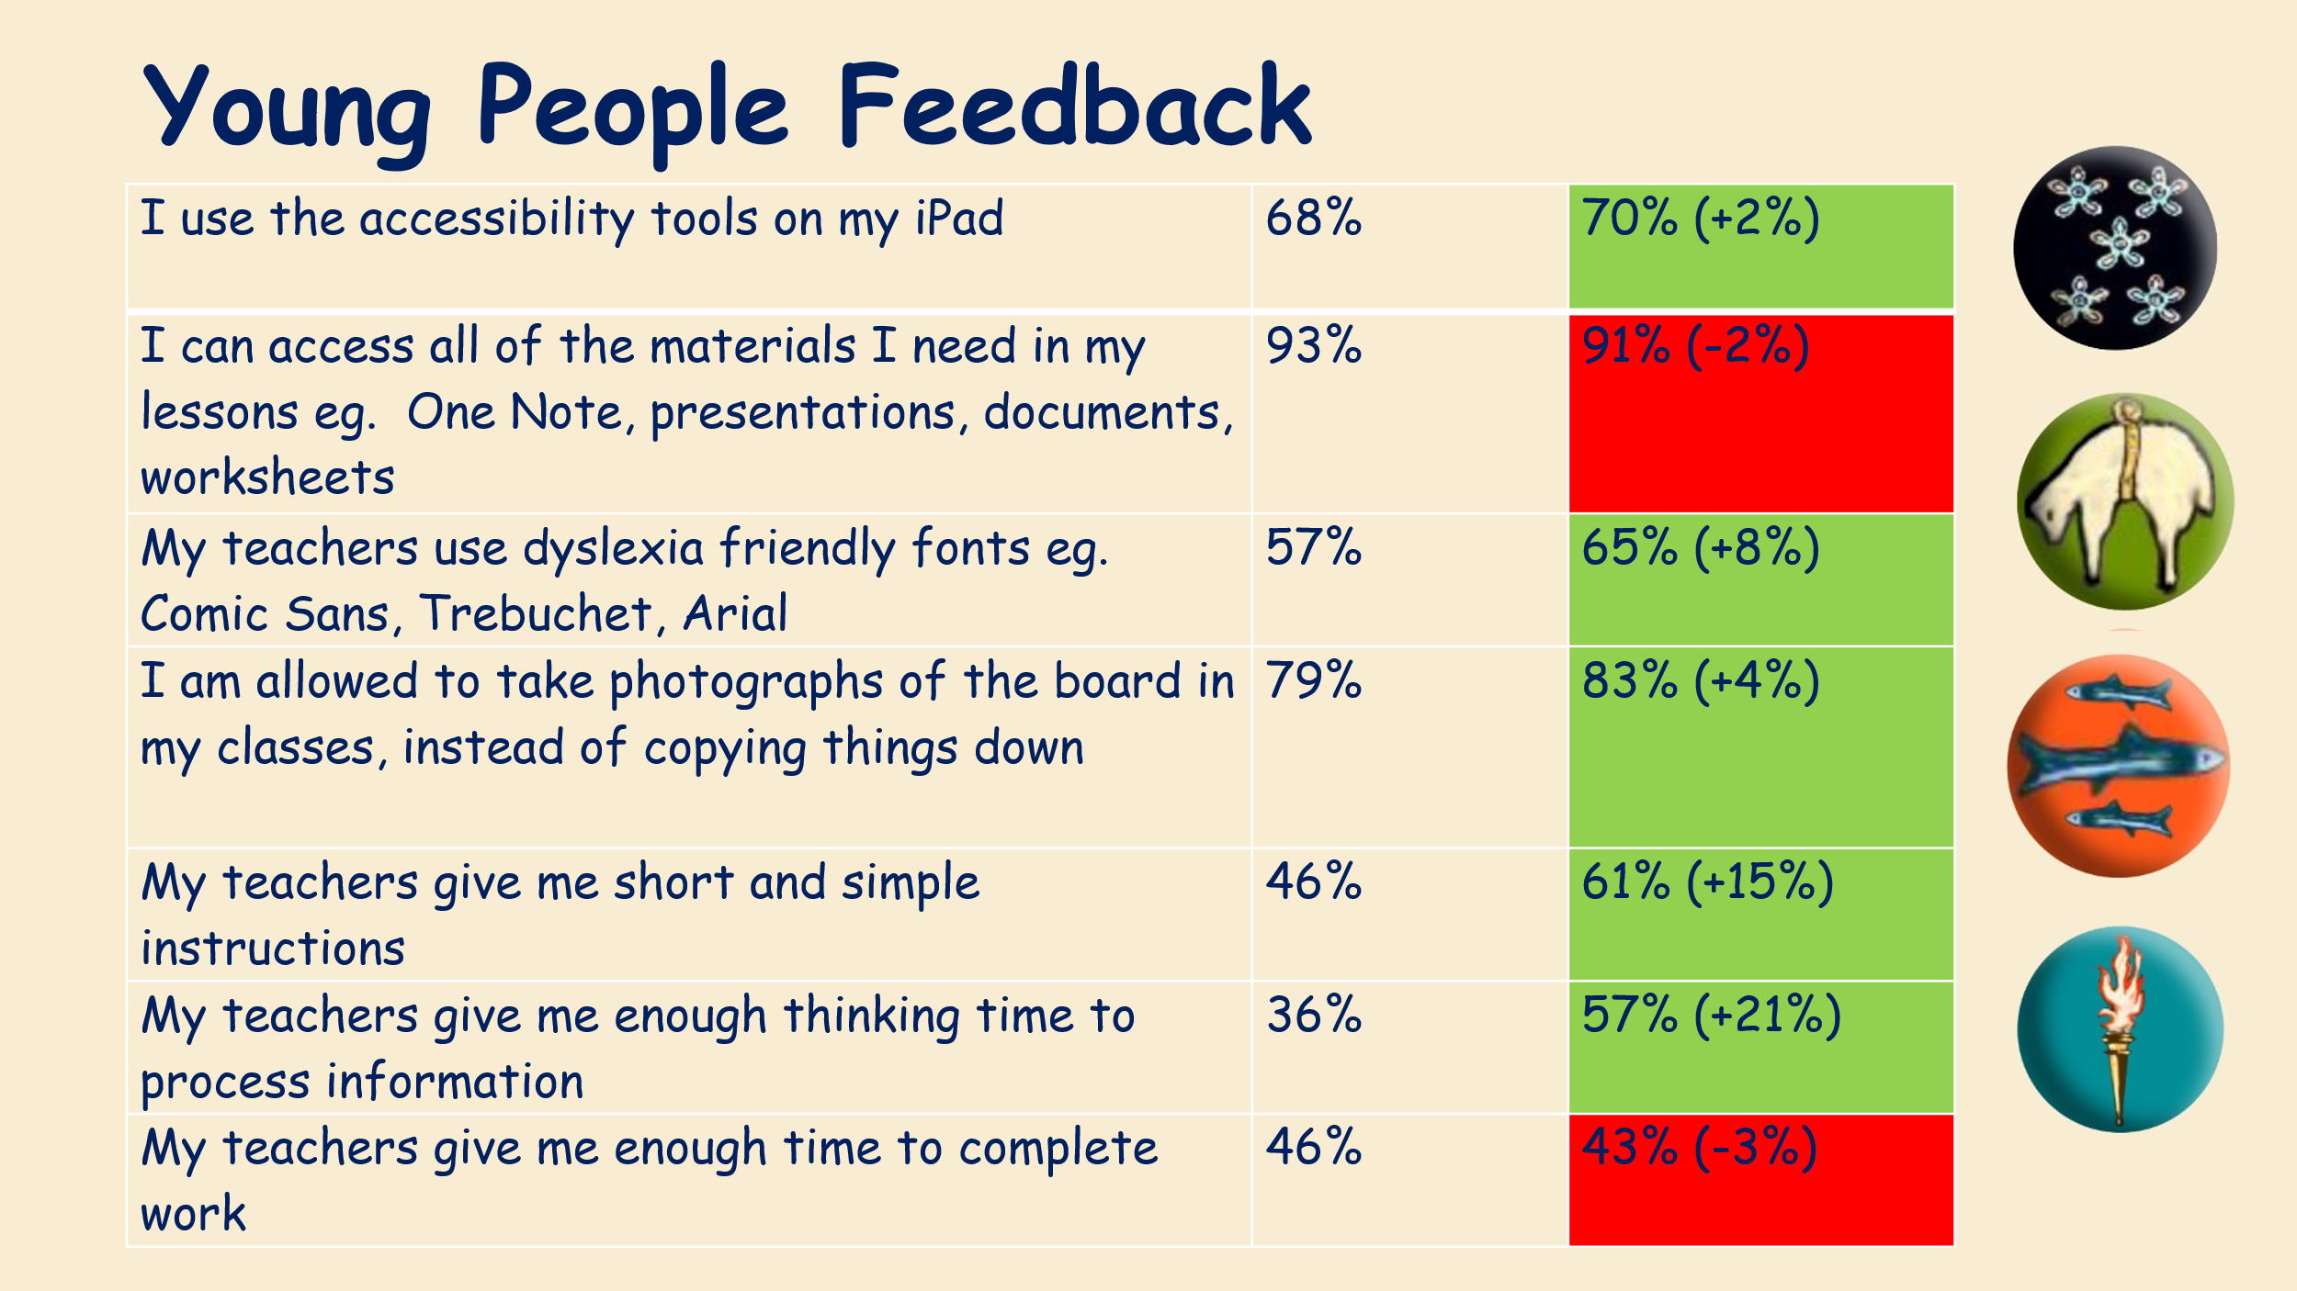

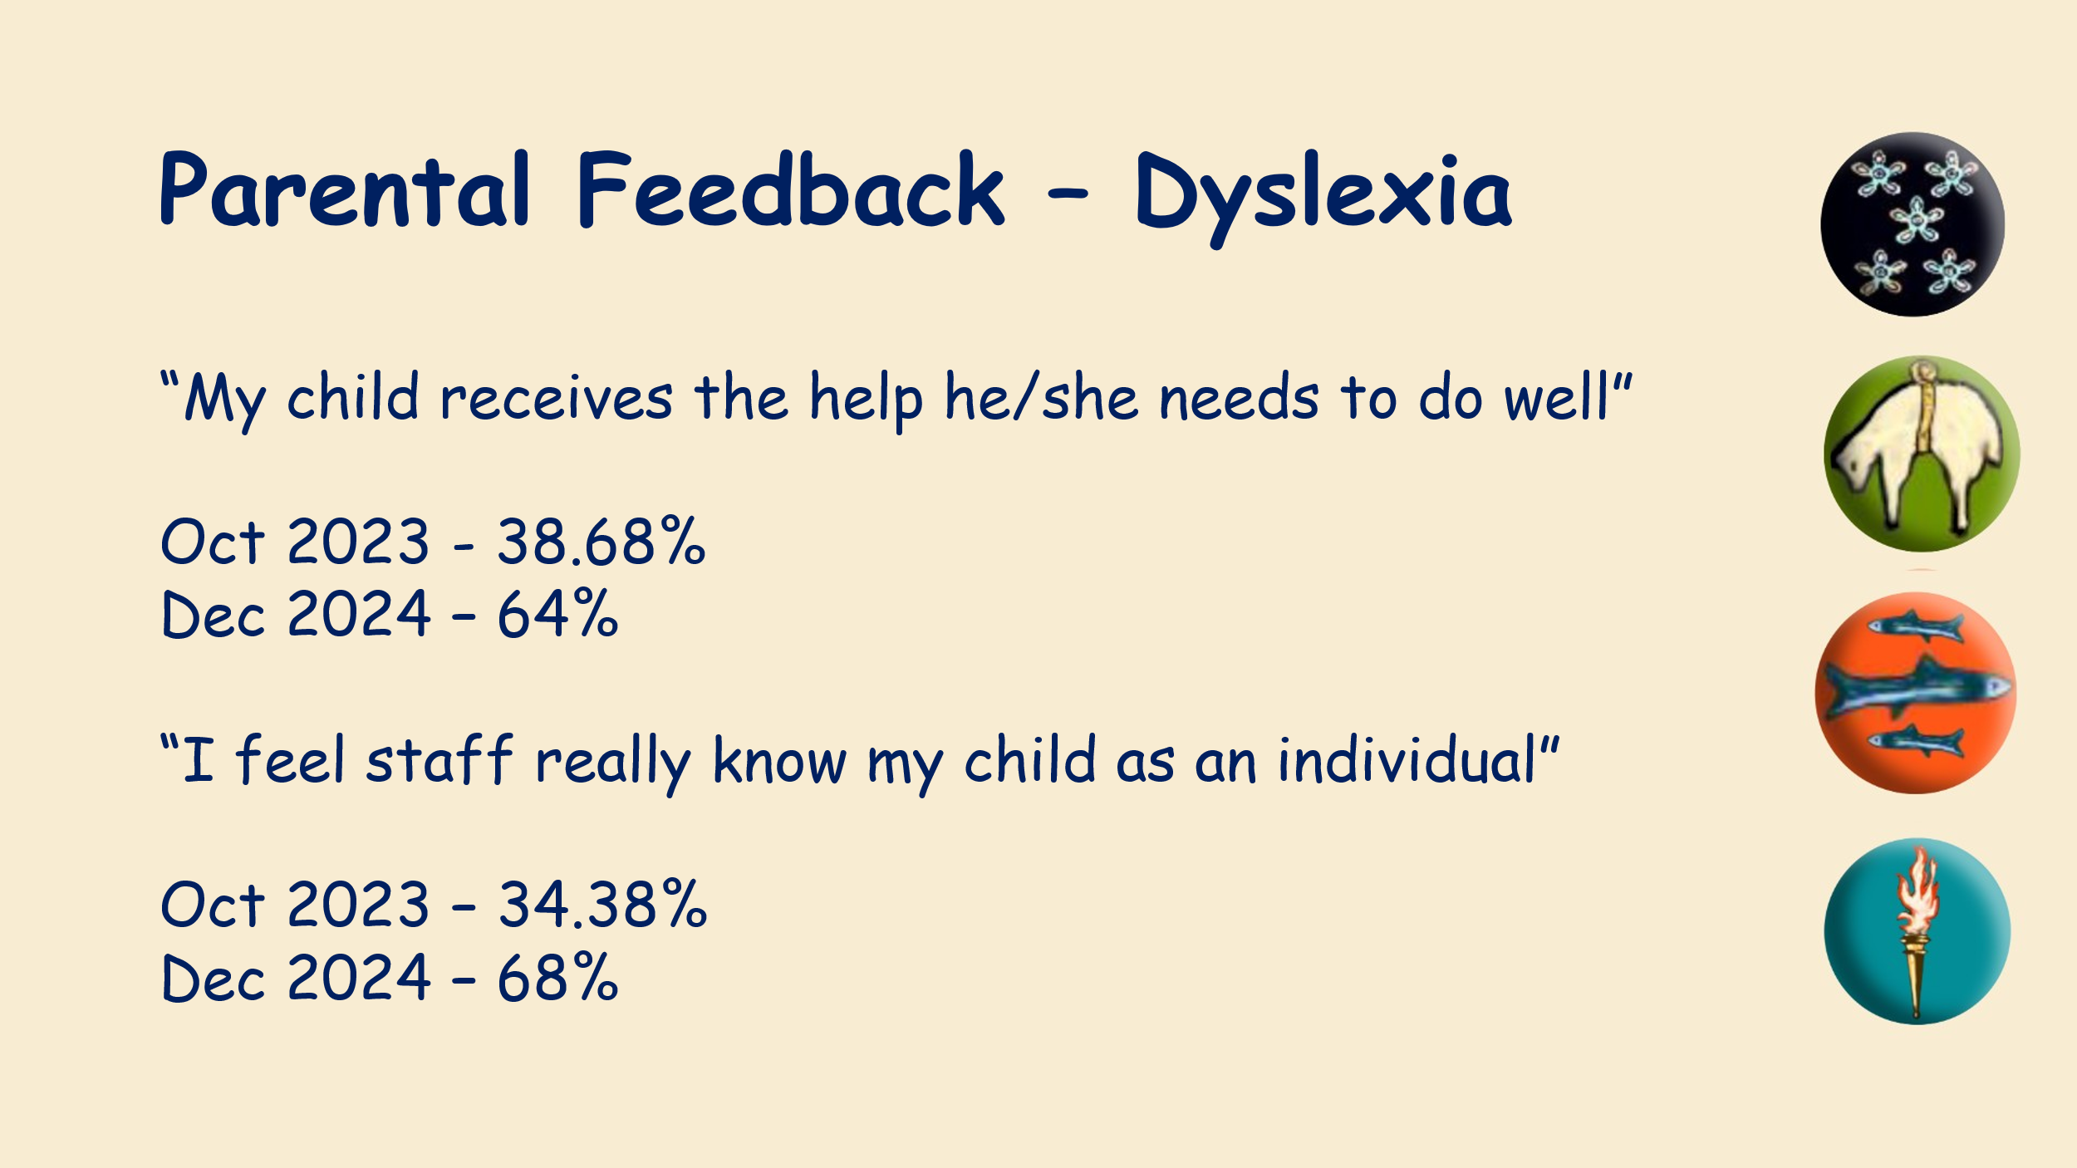
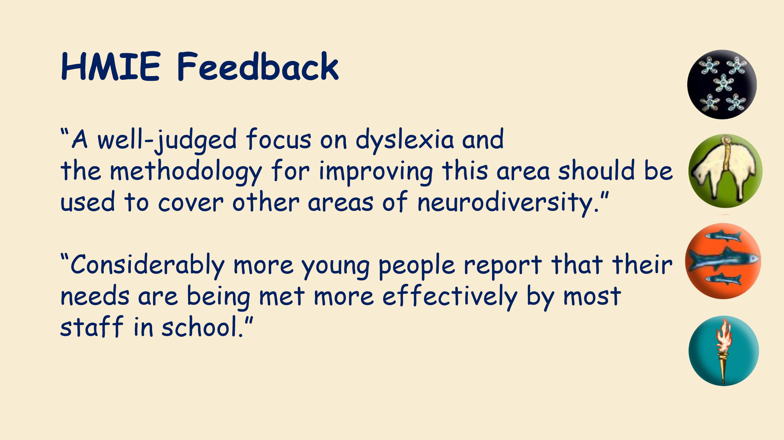
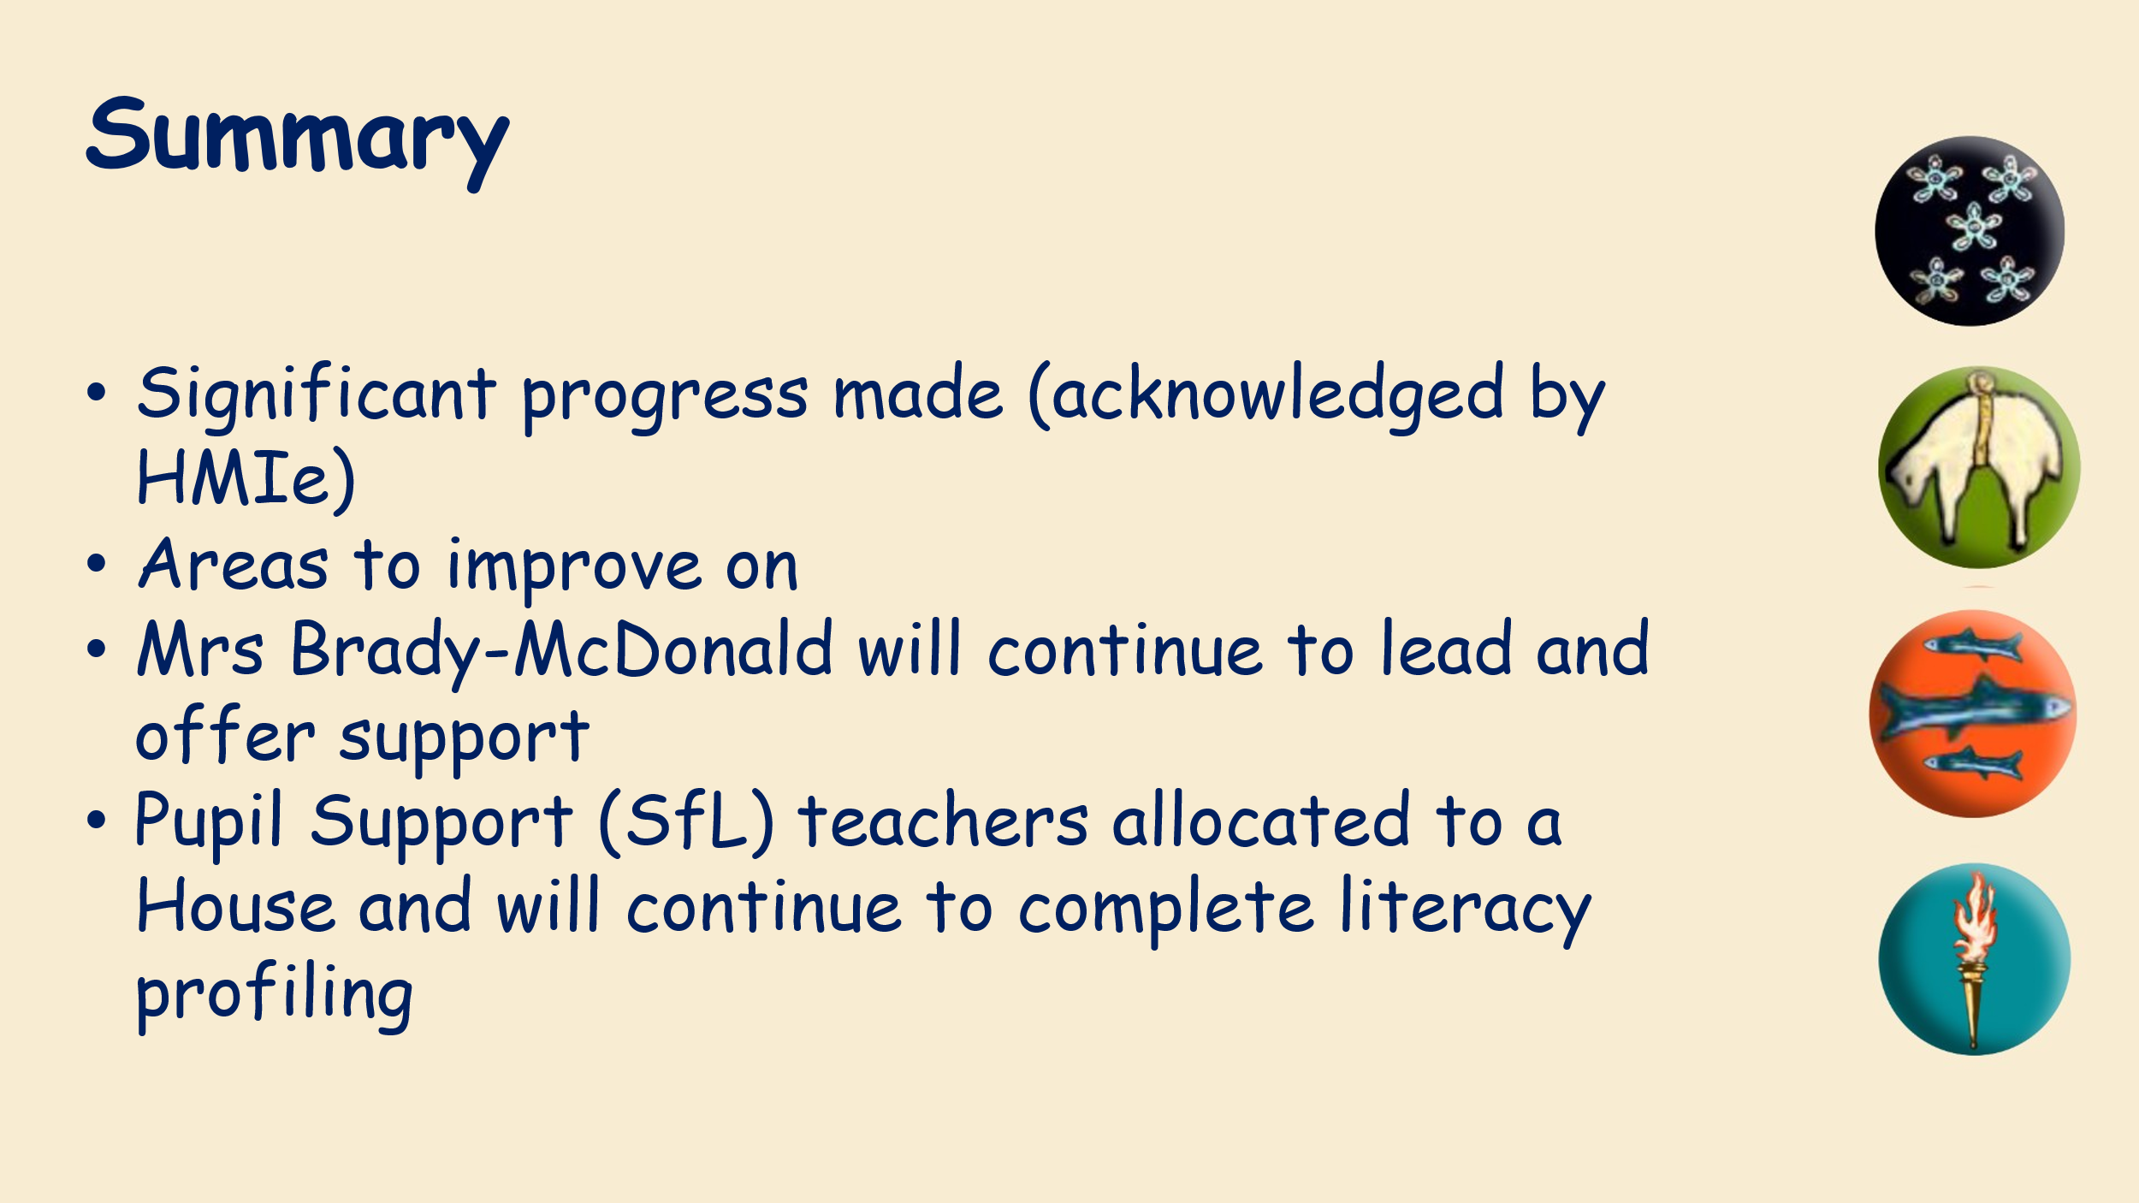

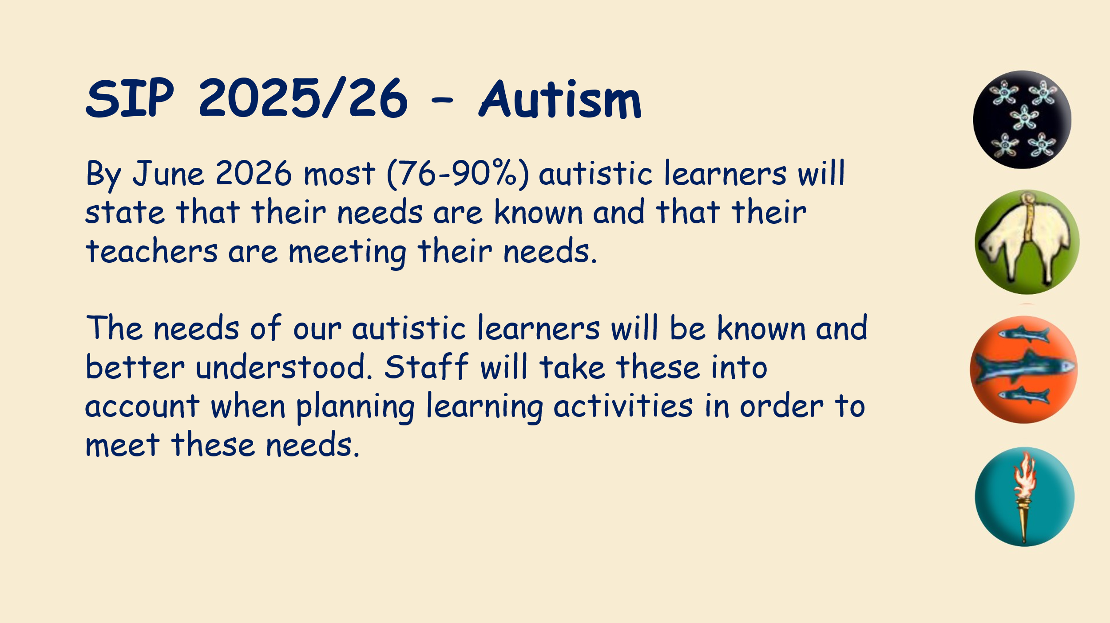
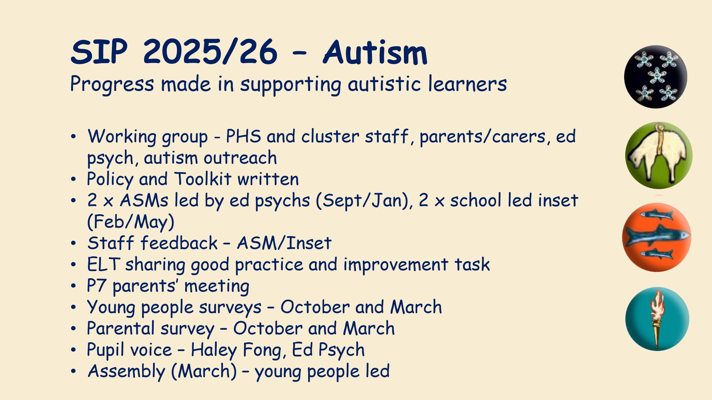
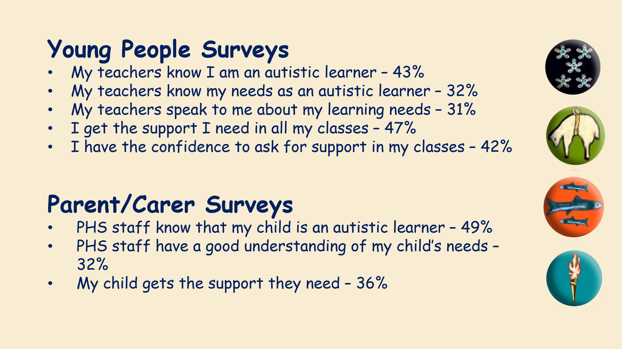

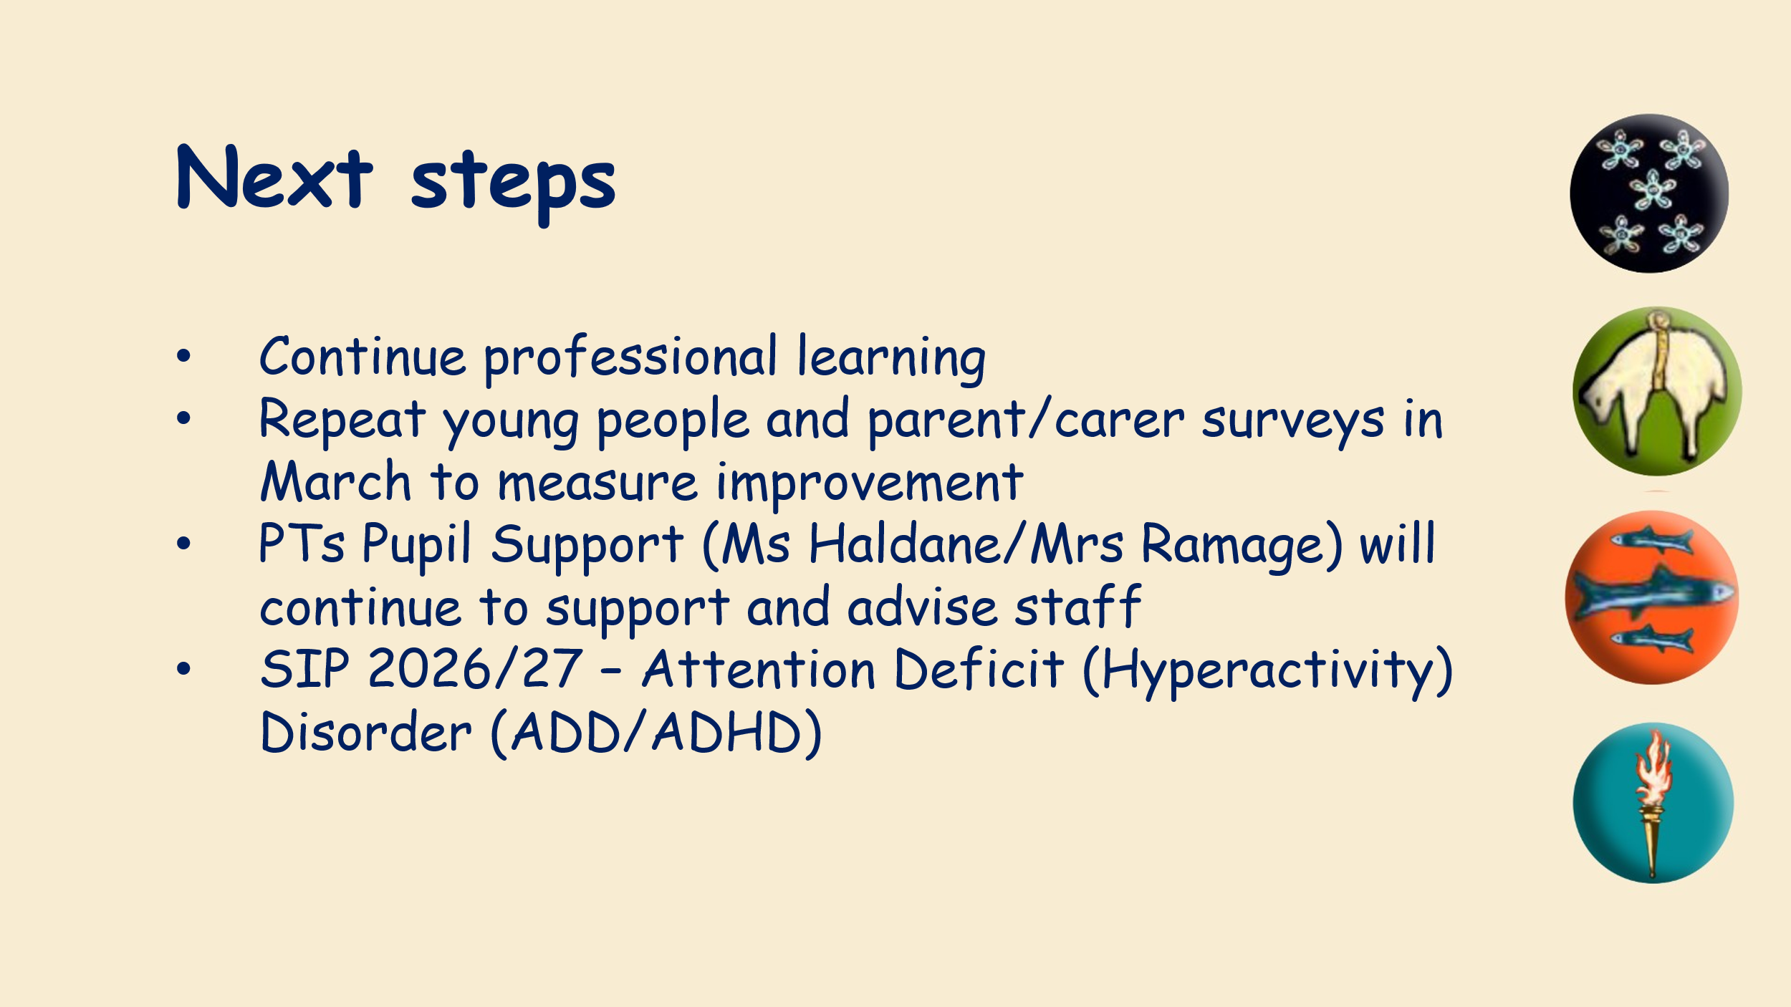
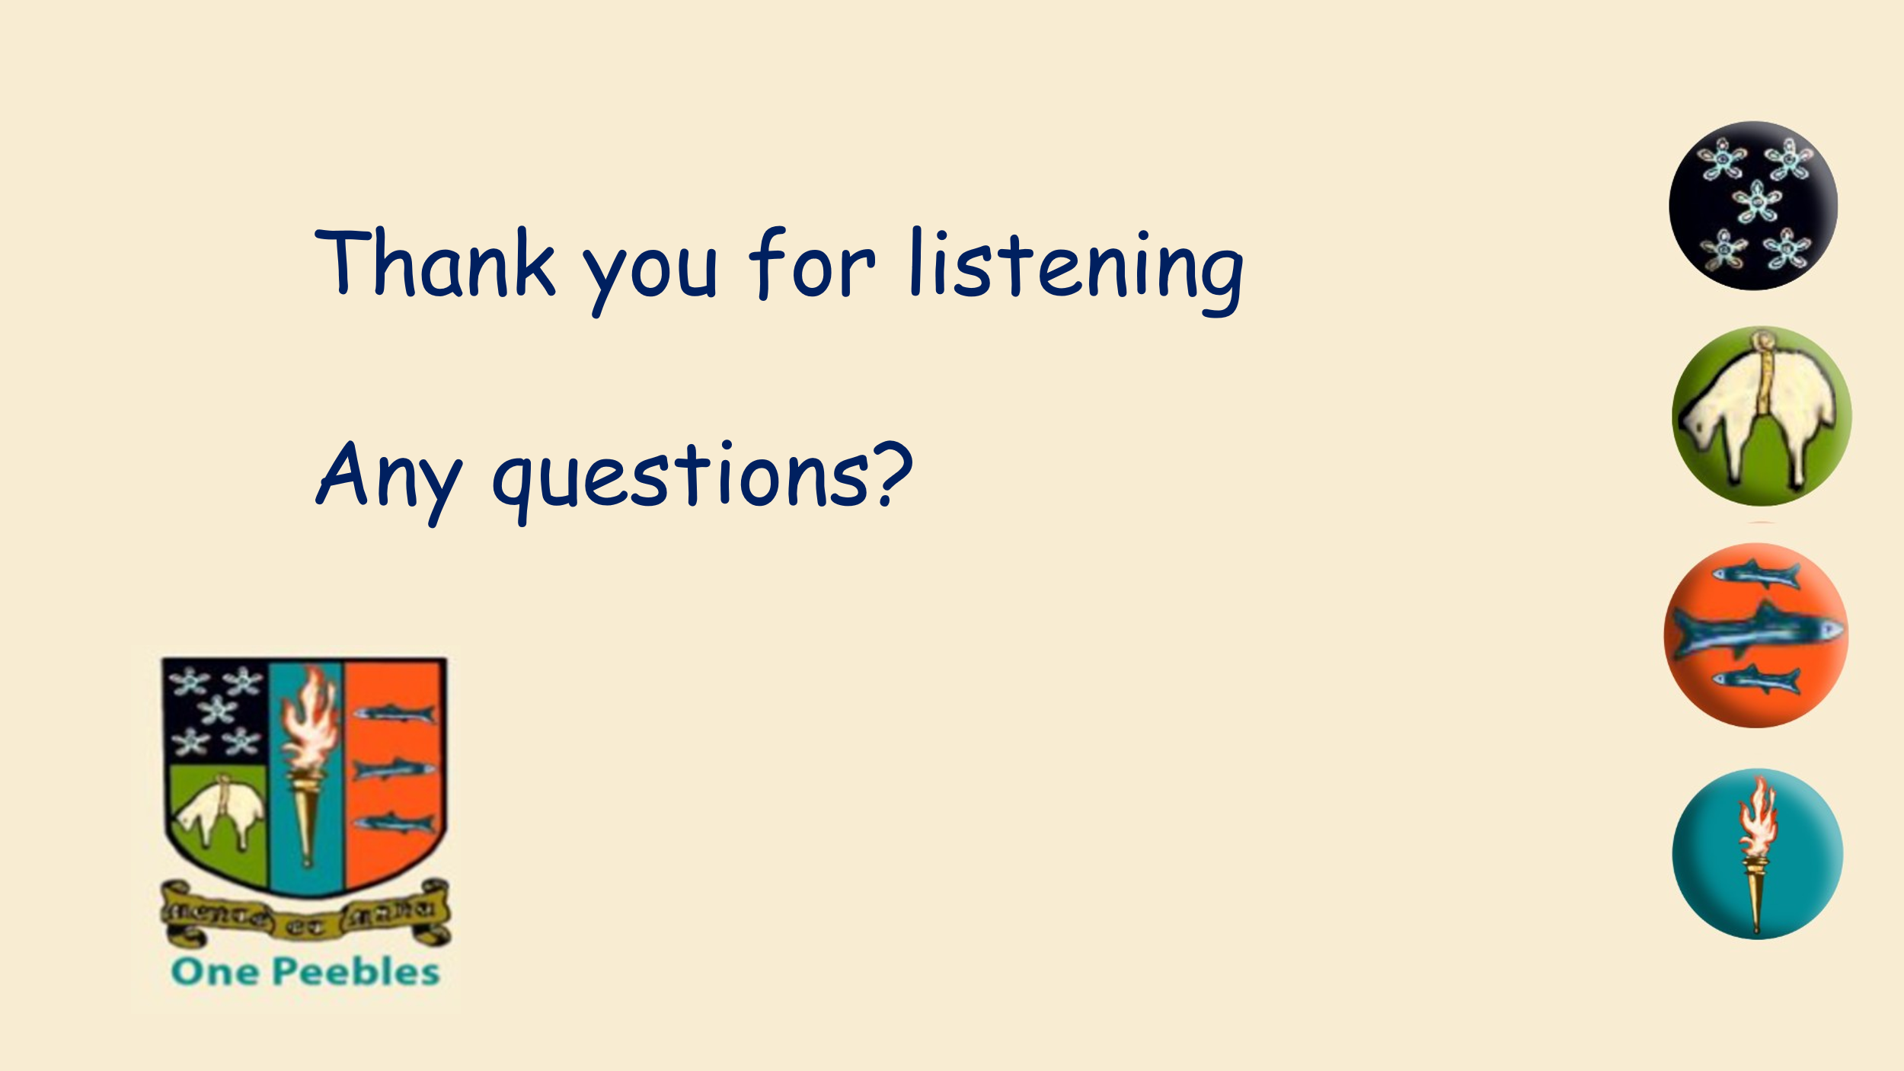

Please get in touch around any of the issues raised at phspc@outlook.com
Helpful Info/Reminders

Parent Council Meeting Dates for 2025/26 | Post Holders
2 February 2026  18 March 2026  11 May 2026 | Chair – Ellie Johnstone
2 February 2026  18 March 2026  11 May 2026 | Vice Chair – Tristan Compton
2 February 2026  18 March 2026  11 May 2026 | Secretary – Claire Barrett
2 February 2026  18 March 2026  11 May 2026 | Communications Officer –
2 February 2026  18 March 2026  11 May 2026 | Event Coordinator – Gillian Moran
2 February 2026  18 March 2026  11 May 2026 | Friends of Peebles High School SCIO representative
2 February 2026  18 March 2026  11 May 2026 | Property Working Group Lead – Tristan Compton
2 February 2026  18 March 2026  11 May 2026 | Taskforce Coordinator – post vacant

We welcome interested parents & carers on the Parent Council as general members or working group members. We simply ask that you try to attend meetings regularly. If you would like to be an ordinary member or join a specific working group, please email your details to: phspc@outlook.com

Any parent or carer interested in supporting the Friends of PHS charity with running fundraising activities should get in touch at mailto:FriendsofPHS@outlook.com

Website: phsparents.org.uk Facebook: PHS Parents – can contact us via Messenger
Twitter: @PHSparents @PeeblesHigh

Parent Council Action tracker 2024/25
Meeting | Item/Issue | Action | Who | Update
Sept 25 | Could Online resources for Physics and Maths please be shared with all automatically | HT to look into this | HT
Sept 25 | What will happen with deposits for lockers/keys when we move to the new school? | HT to check | HT
Mar 25 | University Aspirations Group – Medicine parent helper | HT to follow up with replacement for Medicine parent helper | HT
Mar 25 | PC Parent Survey questions | Tristan & Alex to consider questions for the PC parent survey and send to Chair and HT for review. | Tristan Compton/Alex Corbishley
Mar 25 | Duke of Edinburgh Awards presentation | HT to look into why these have not been presented to pupils | HT
Feb 25 | Parent FAQs on new school and move | PC (Tristan/Ellie) to send Mr Ryalls the collated FAQs and comments from parents to form basis of communication to parents. | PC
Nov 24 | Smoking/vaping on school bus | Chair to pass this onto HT | HT
Nov 24 | Parent Council Survey | Chair & HT to discuss best timing for 2025 survey | Chair/HT
Nov 24 | Street lighting concern | Chair to contact SBC about faulty street lighting in Craigerne Lane and future plans for lighting around new school | PC Chair

